Tour ID: 180615  
Tour Name: Arctic Sights and Northern Lights (11 Days)

Tour destinations: ['Reykjavik', 'Ittoqqortoormiit']

Tour destinations images:

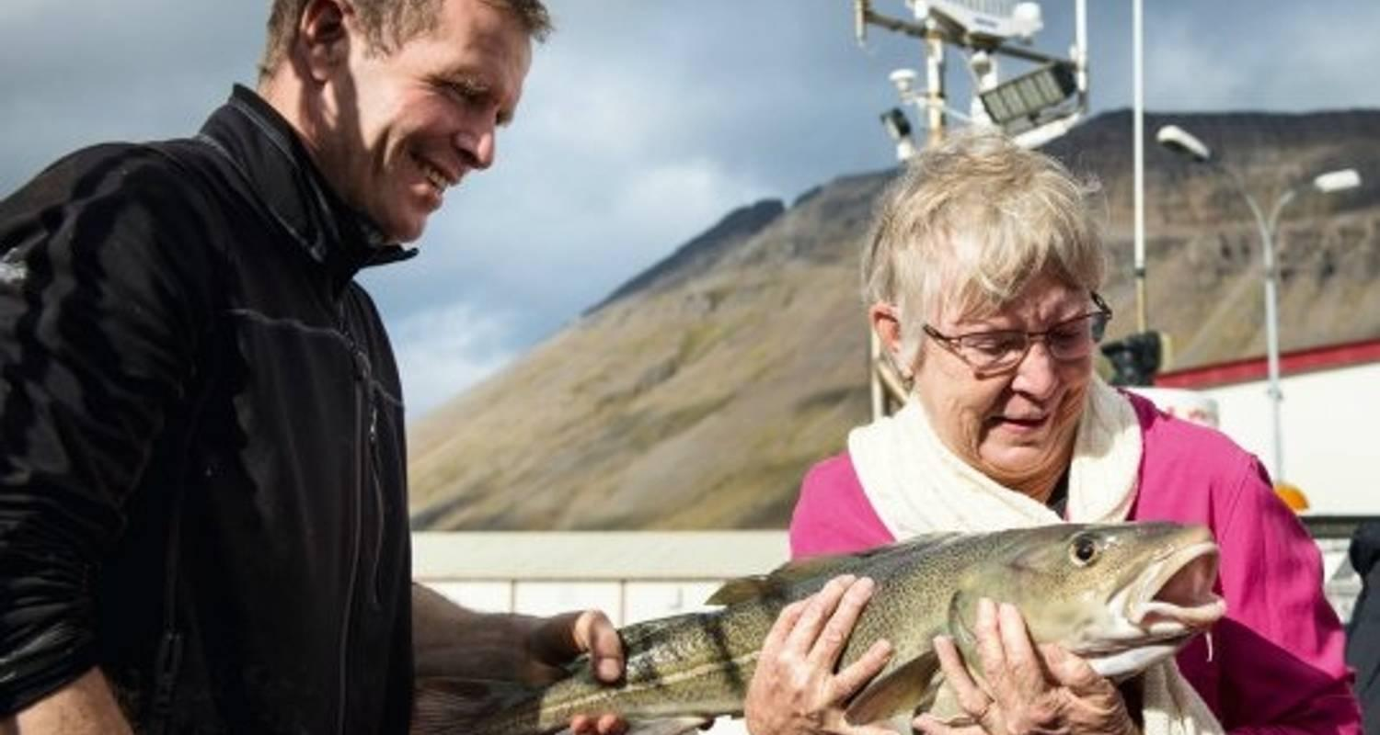

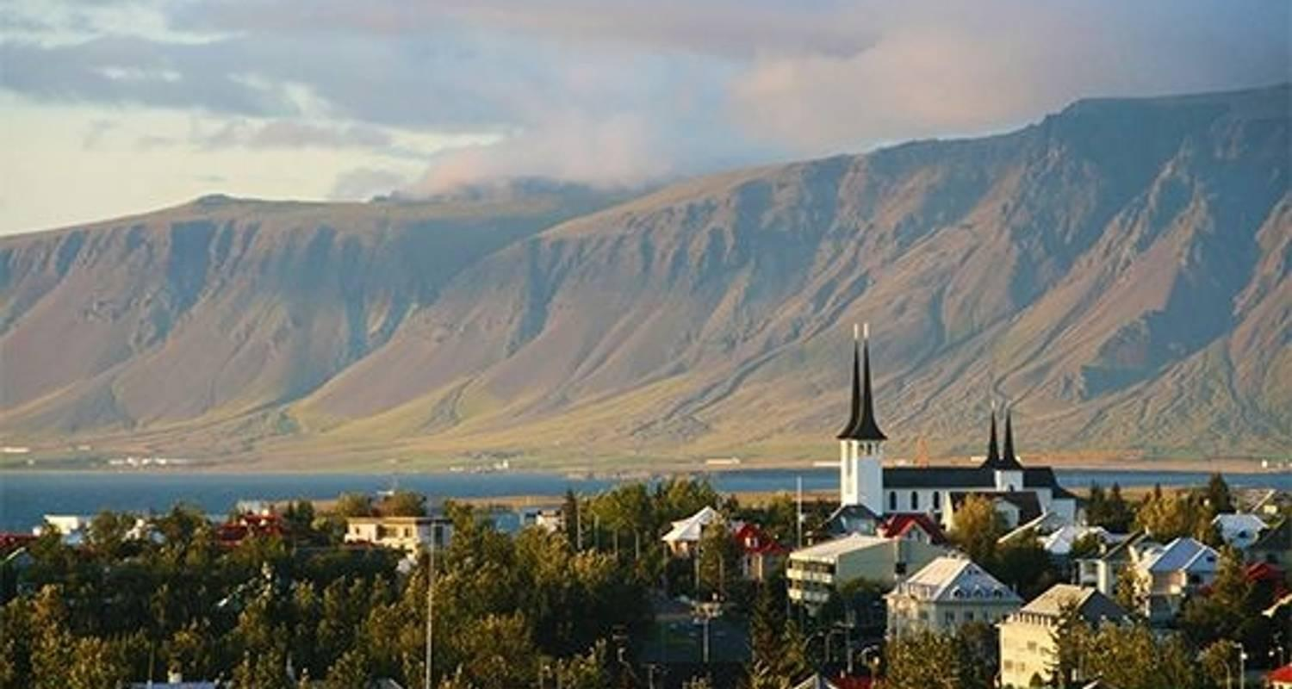

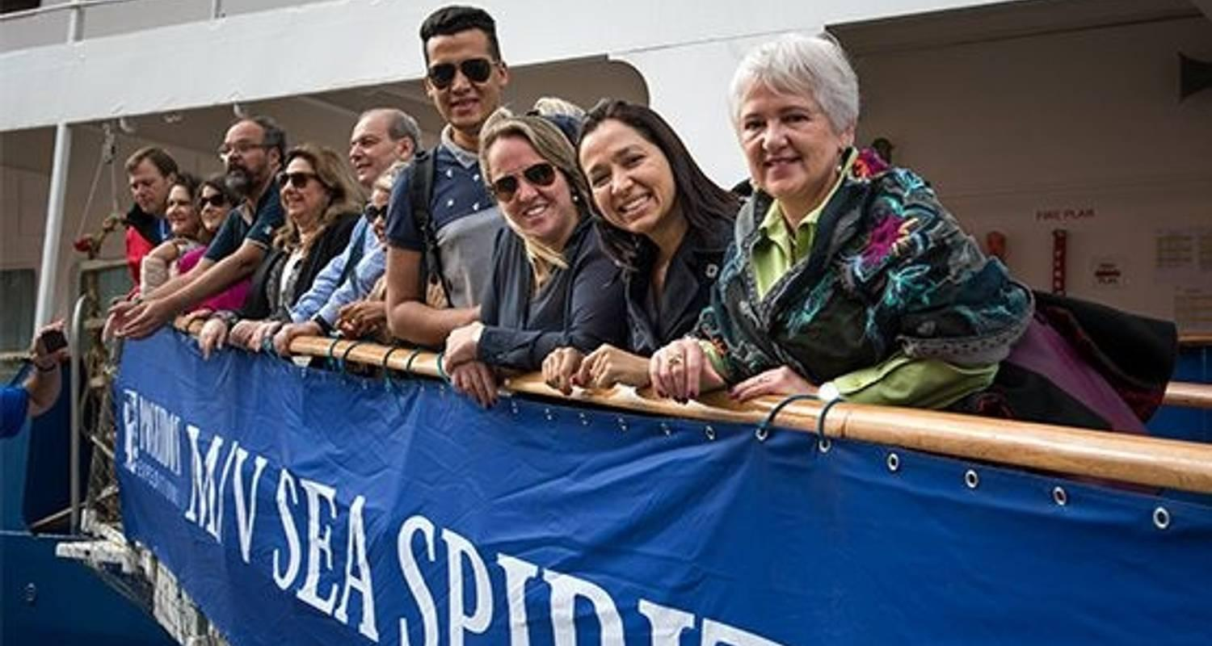

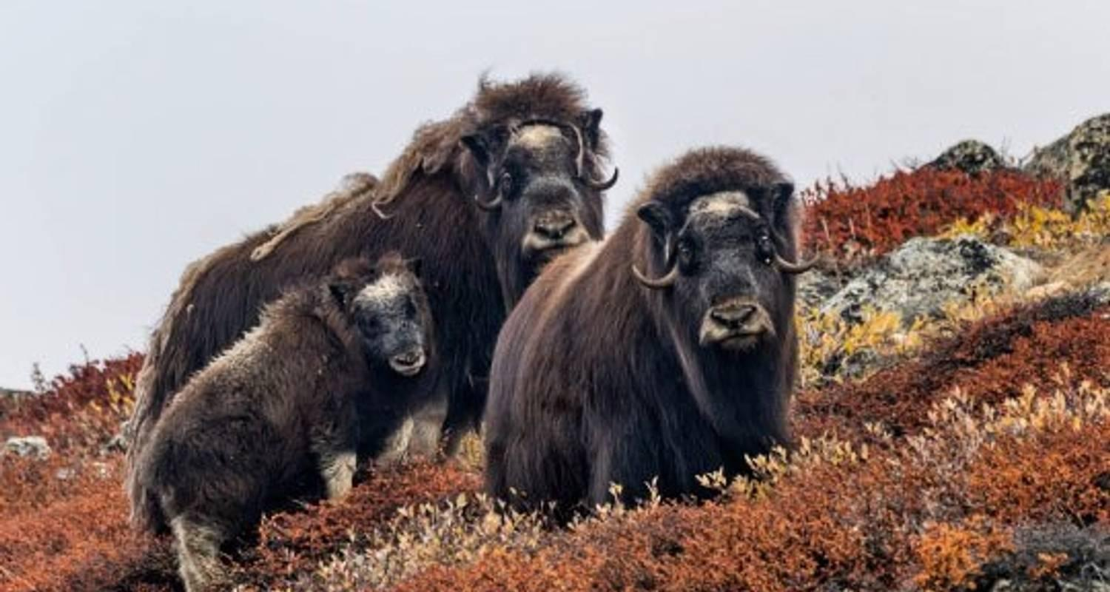

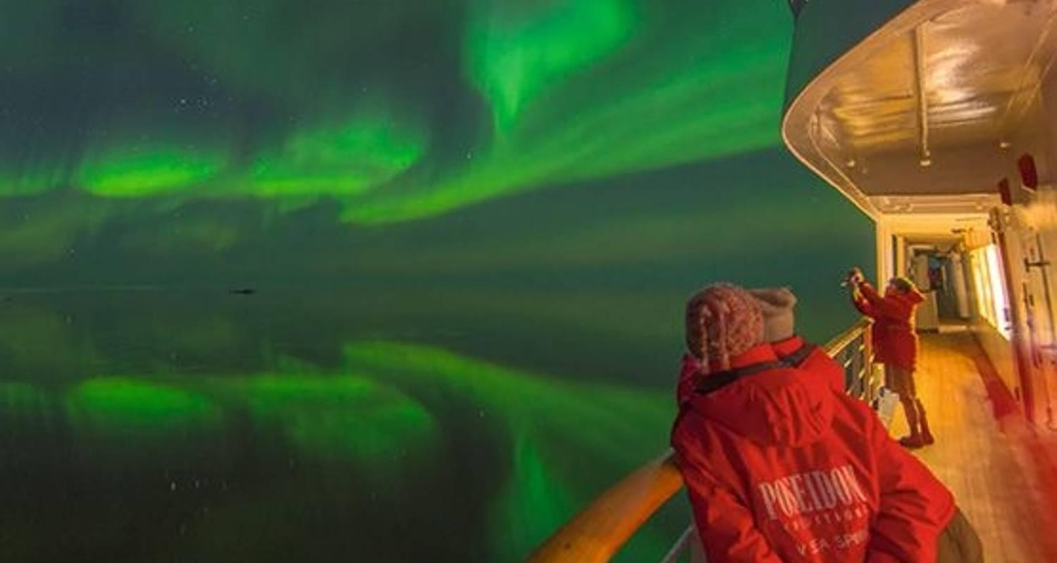

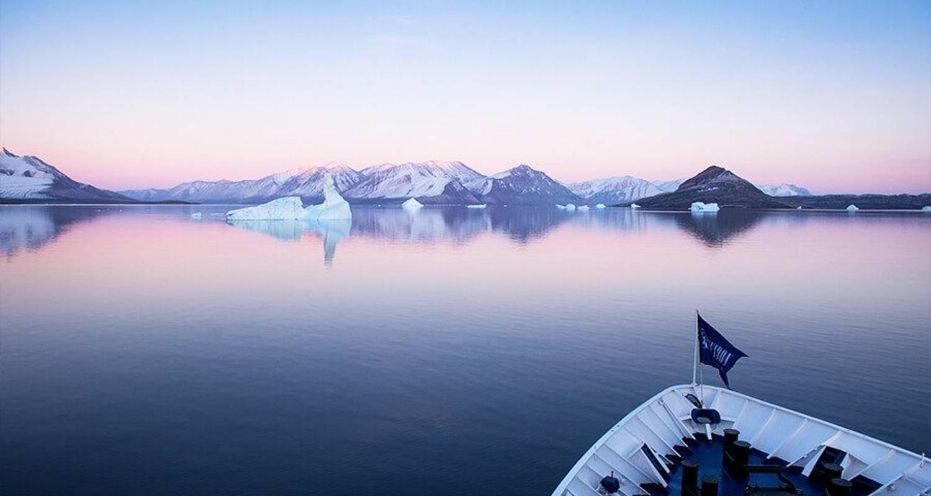

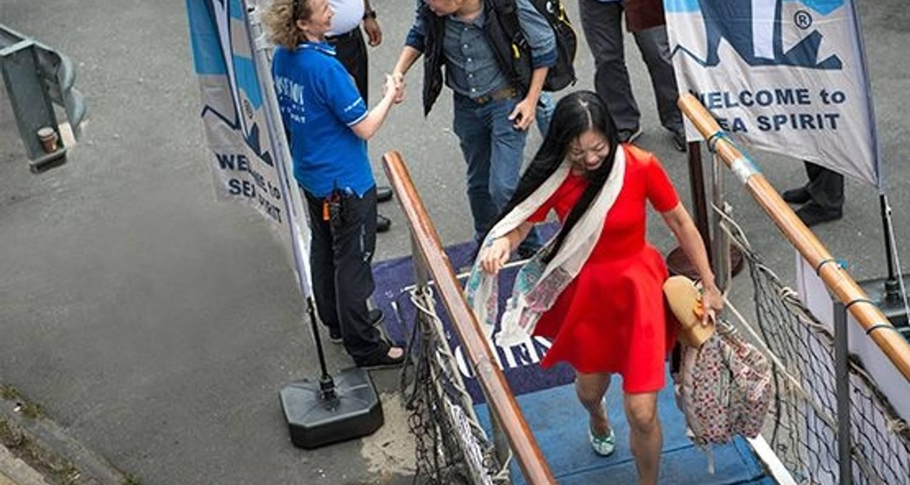

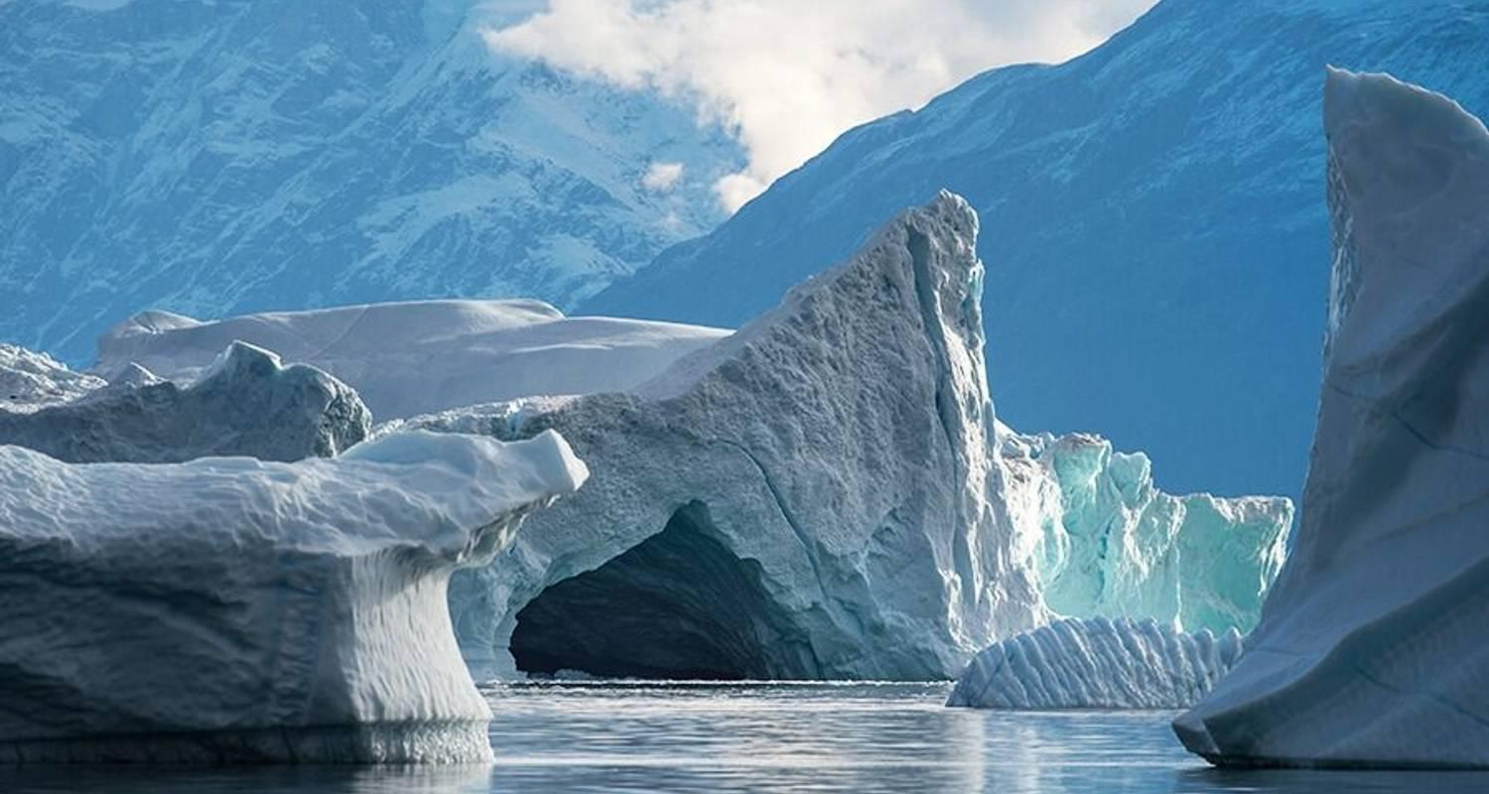

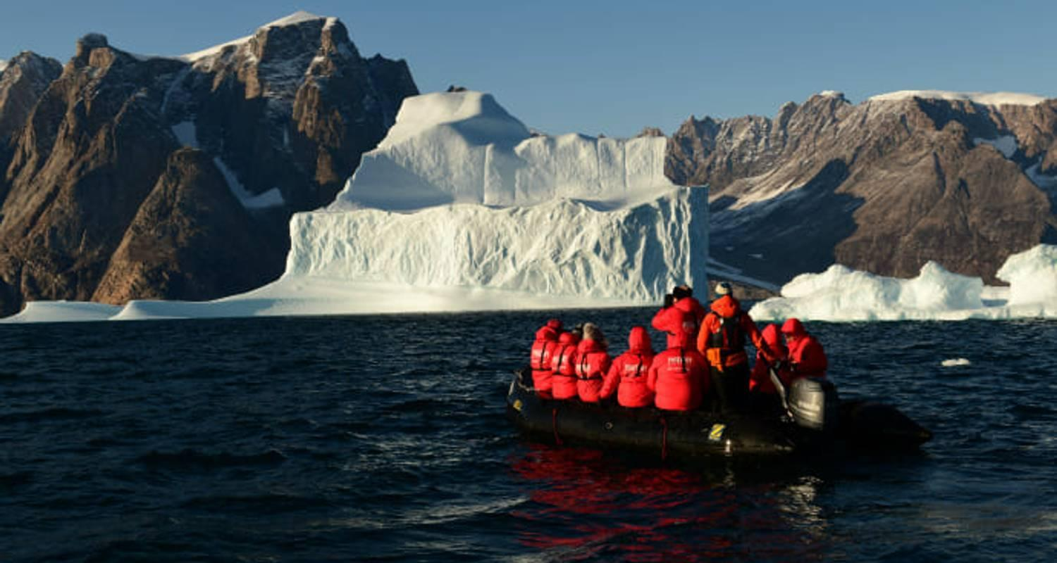

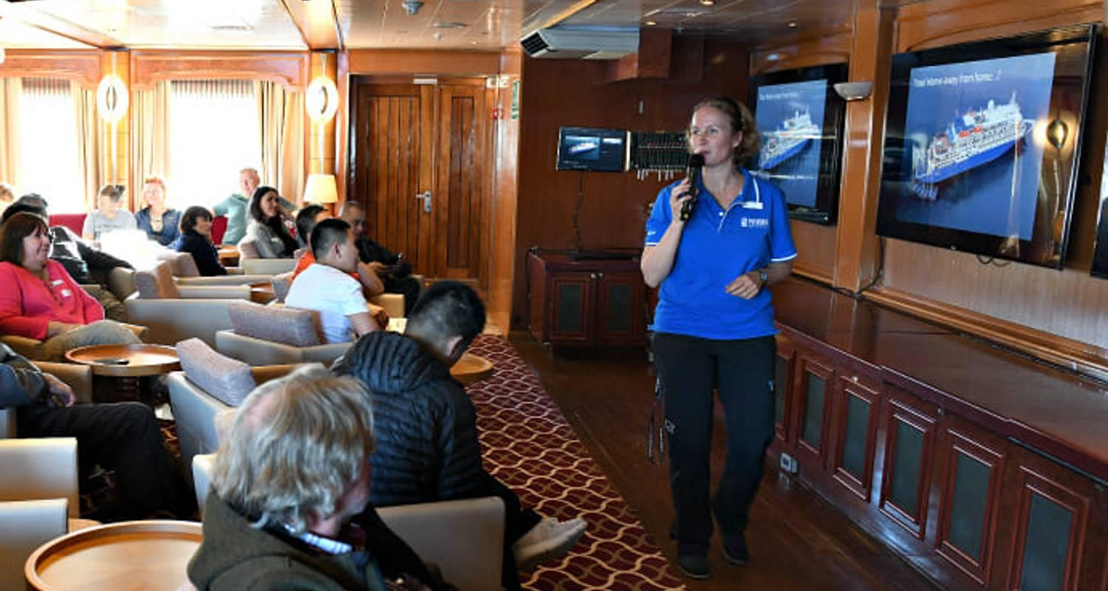

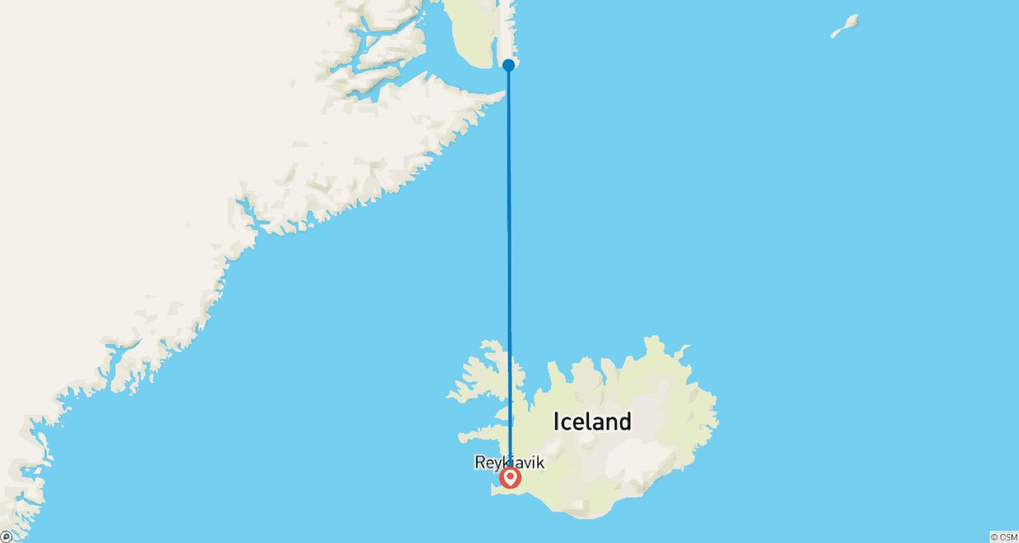

Tour ID: 182988  
Tour Name: 3 Day Winter Minibus Tour: South Coast, Blue Ice Cave, Golden Circle & Northern Lights

Tour destinations: ['Reykjavik', 'Thingvellir National Park', 'Gullfoss', 'Geysir', 'Hvolsvollur', 'Seljaland', 'Skogafoss', 'Solheimajokull', 'Reynisfjara', 'Vik', 'Skaftafell', 'Jokulsarlon', 'Kirkjubaejarklaustur']

Tour destinations images:

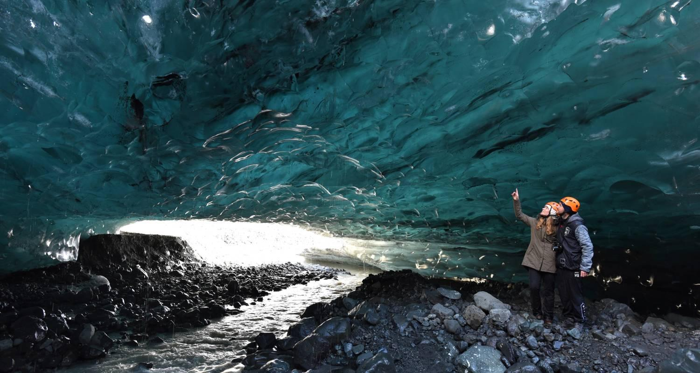

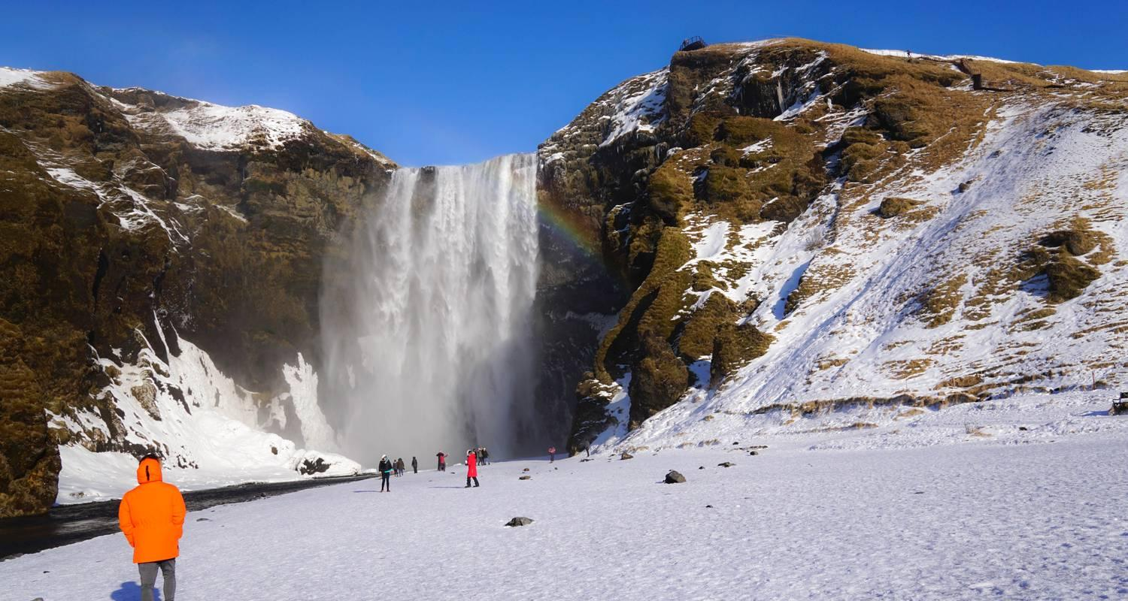

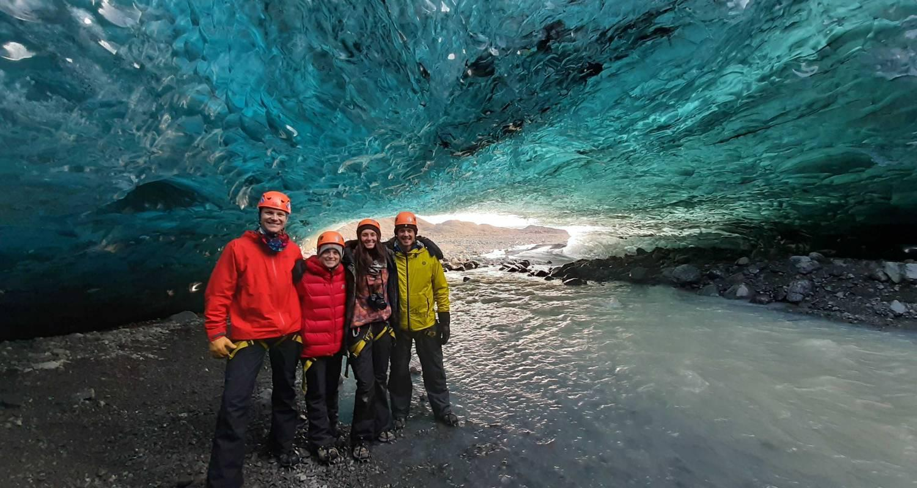

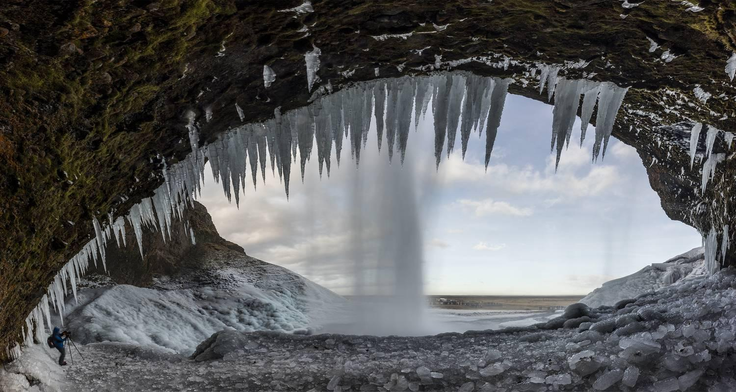

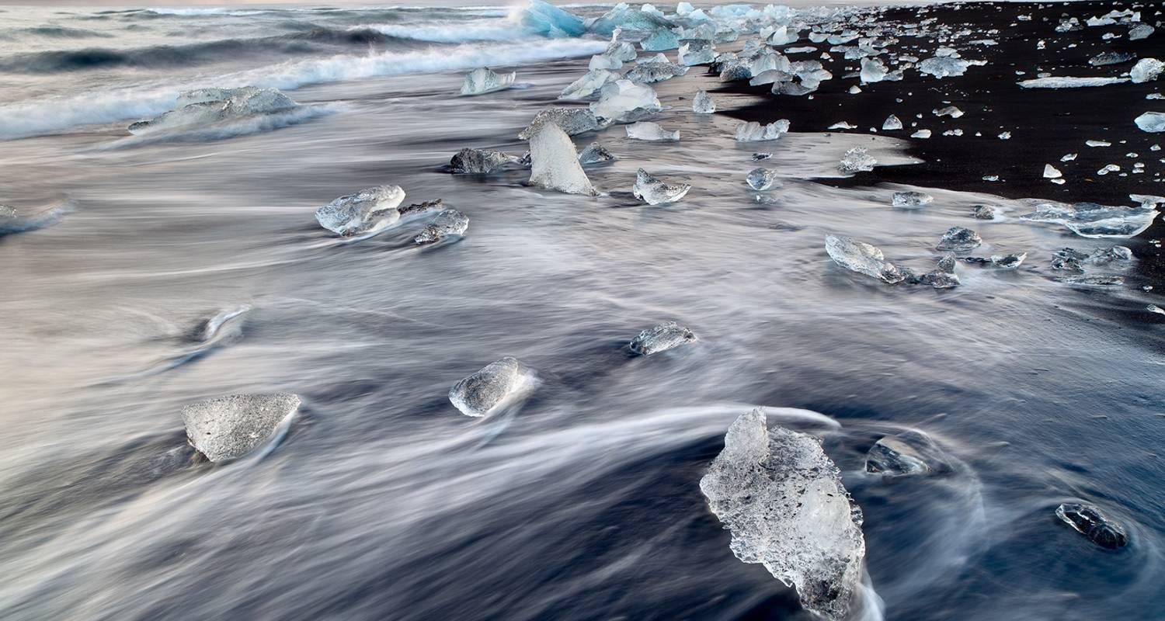

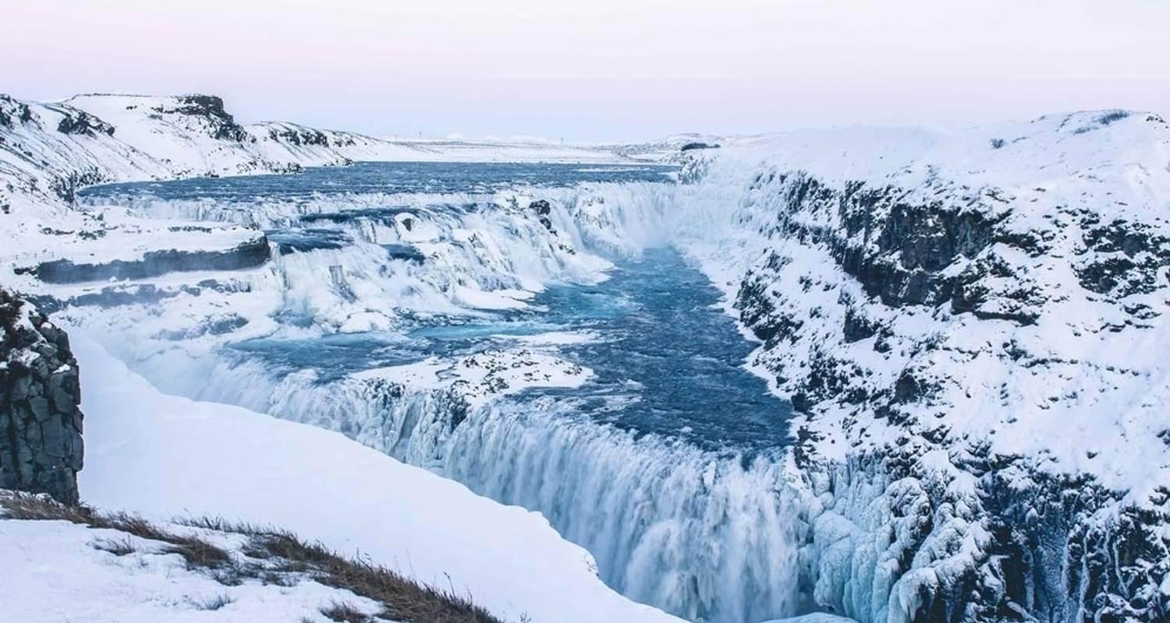

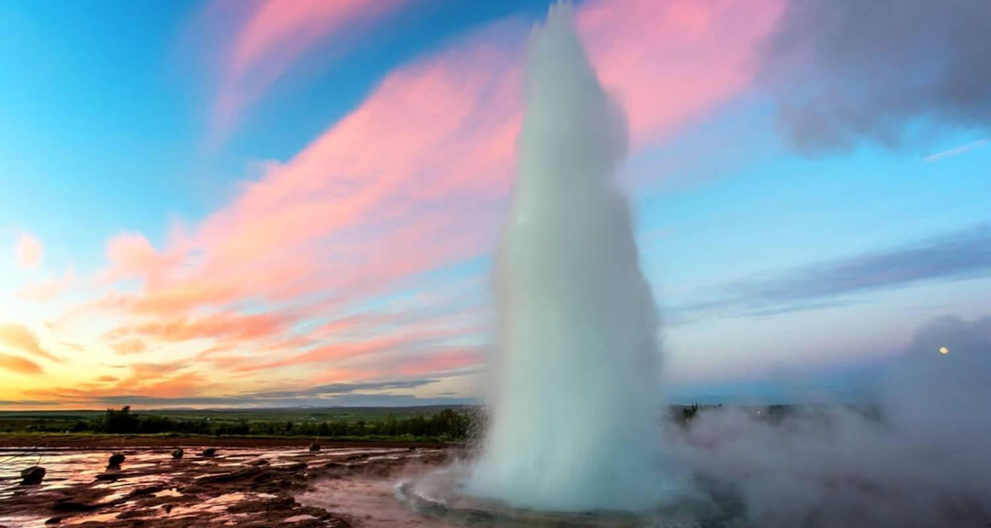

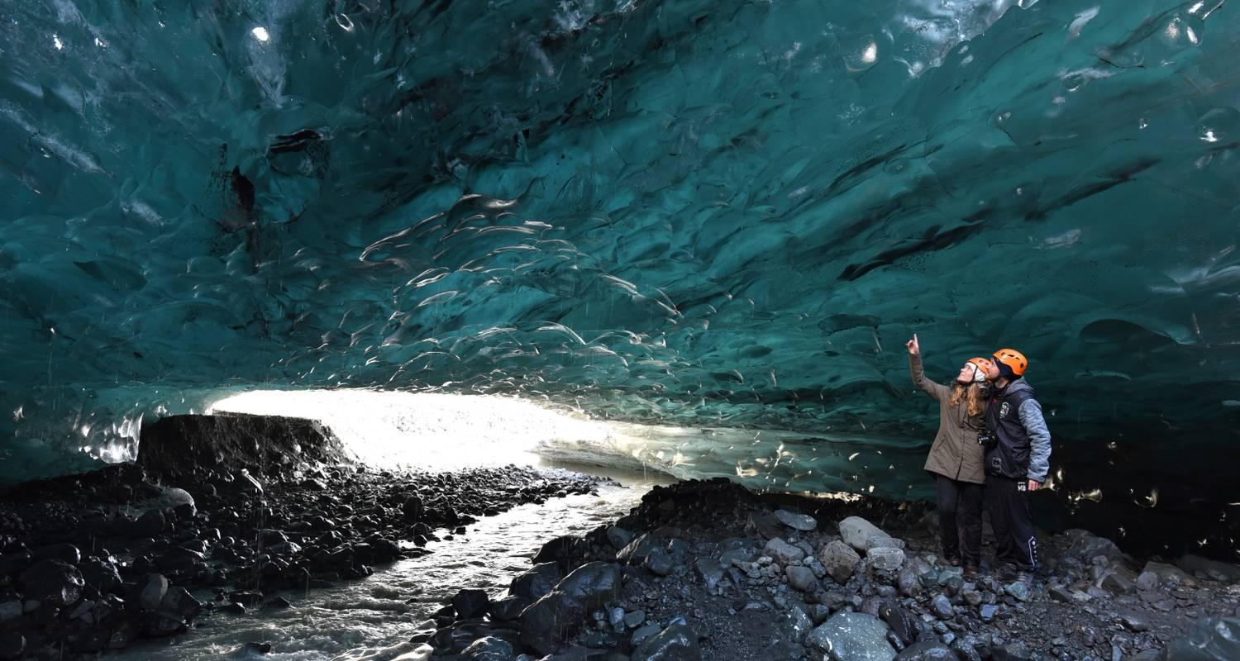

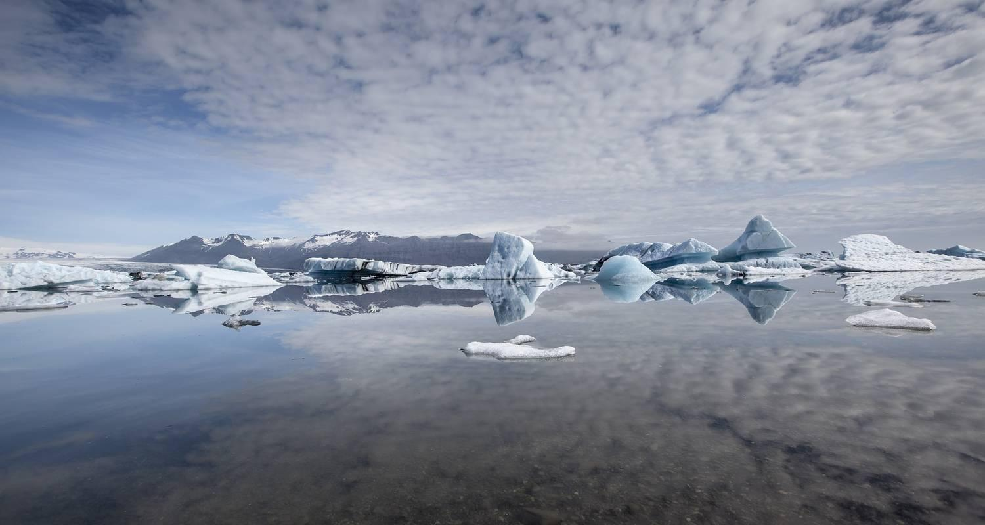

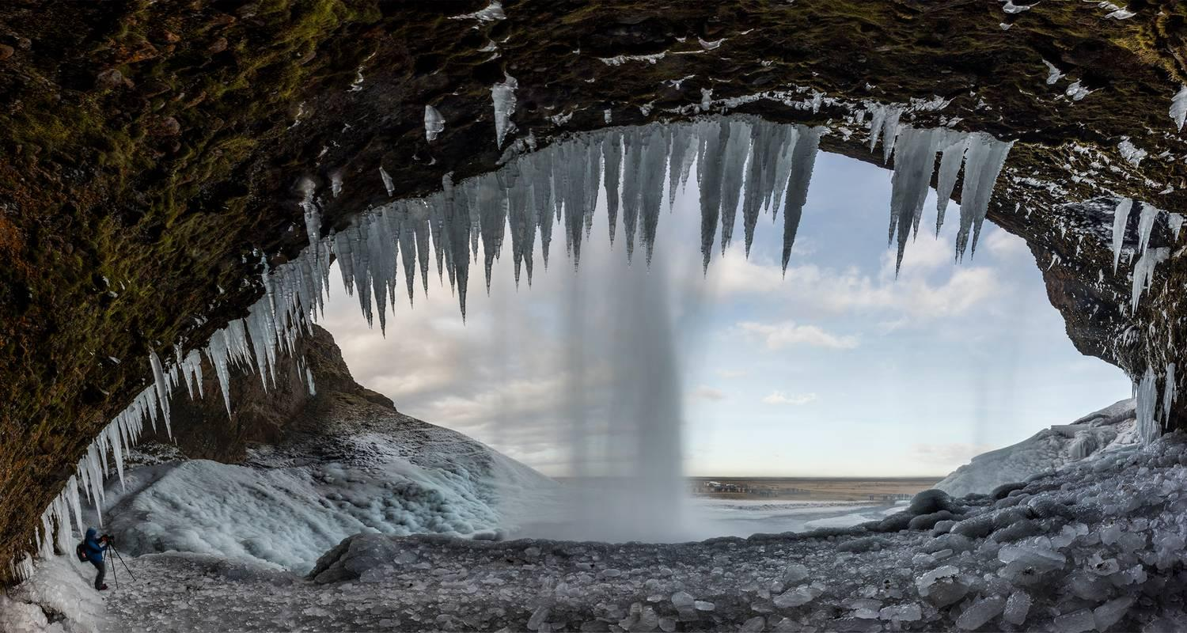

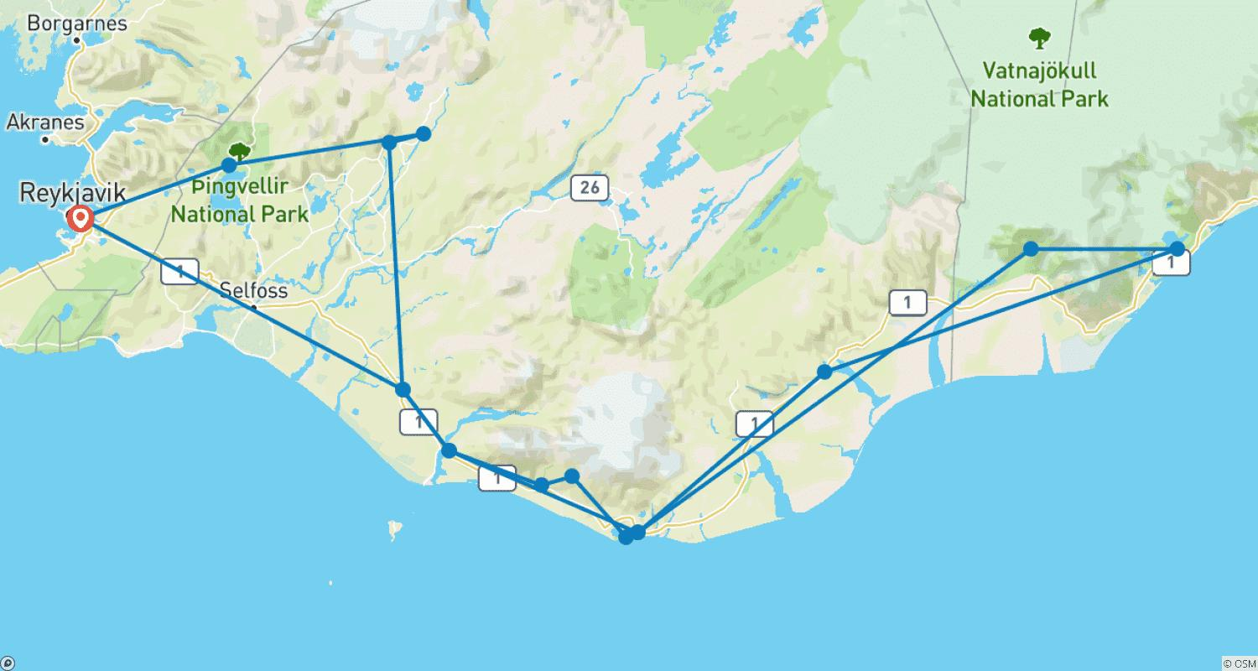

Tour ID: 182992  
Tour Name: 6 Day Around Iceland Minibus Tour

Tour destinations: ['Reykjavik', 'Thingvellir National Park', 'Gullfoss', 'Seljaland', 'Skogafoss', 'Solheimajokull', 'Reynisfjara', 'Vik', 'Skaftafell', 'Jokulsarlon', 'Faskrudsfjordur', 'Egilsstadir', 'Mount Namaskard', 'Hverfjall Volcano', 'Myvatn', 'Godafoss', 'Akureyri', 'Blonduos', 'Borgarnes']

Tour destinations images:

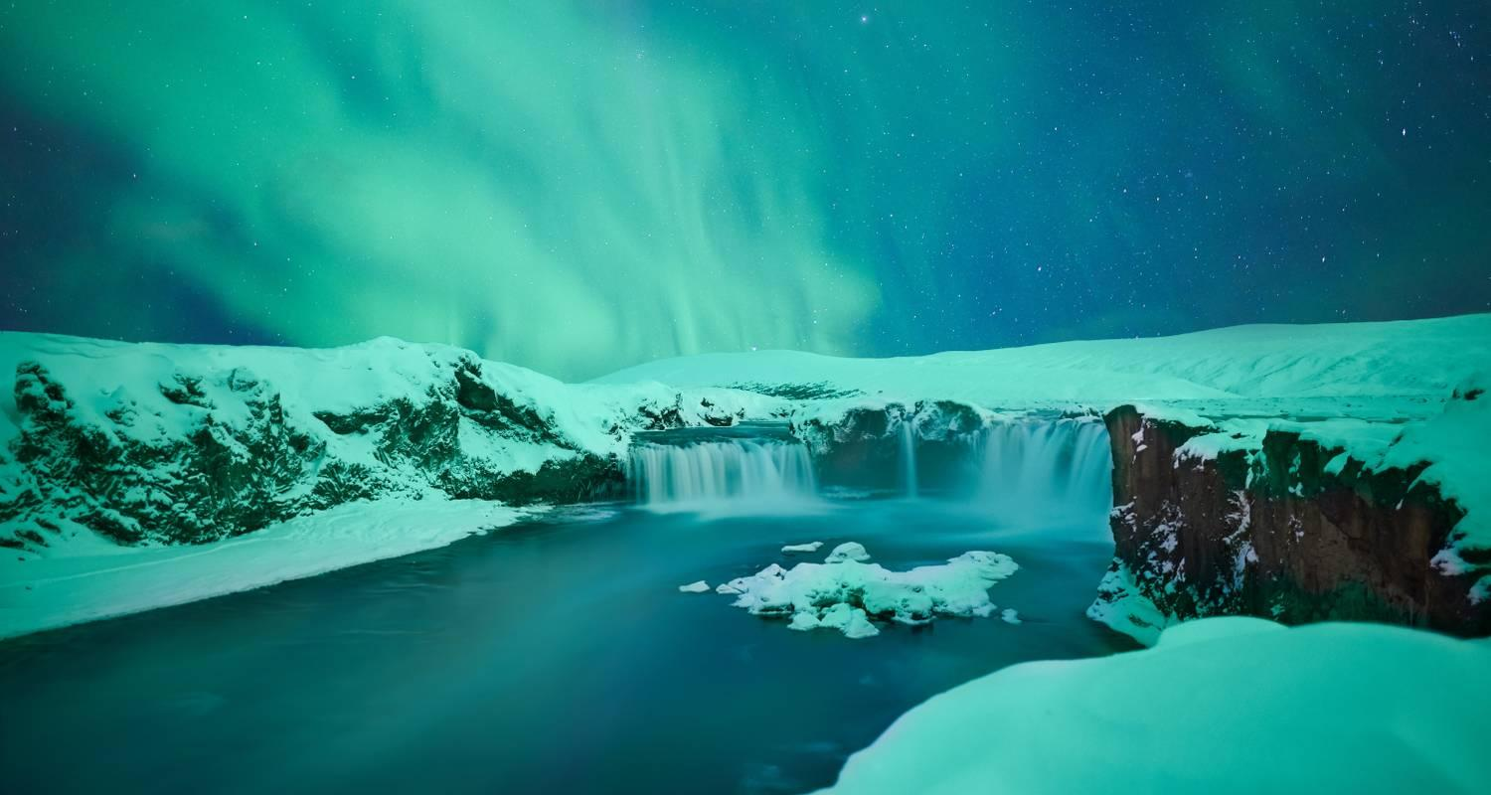

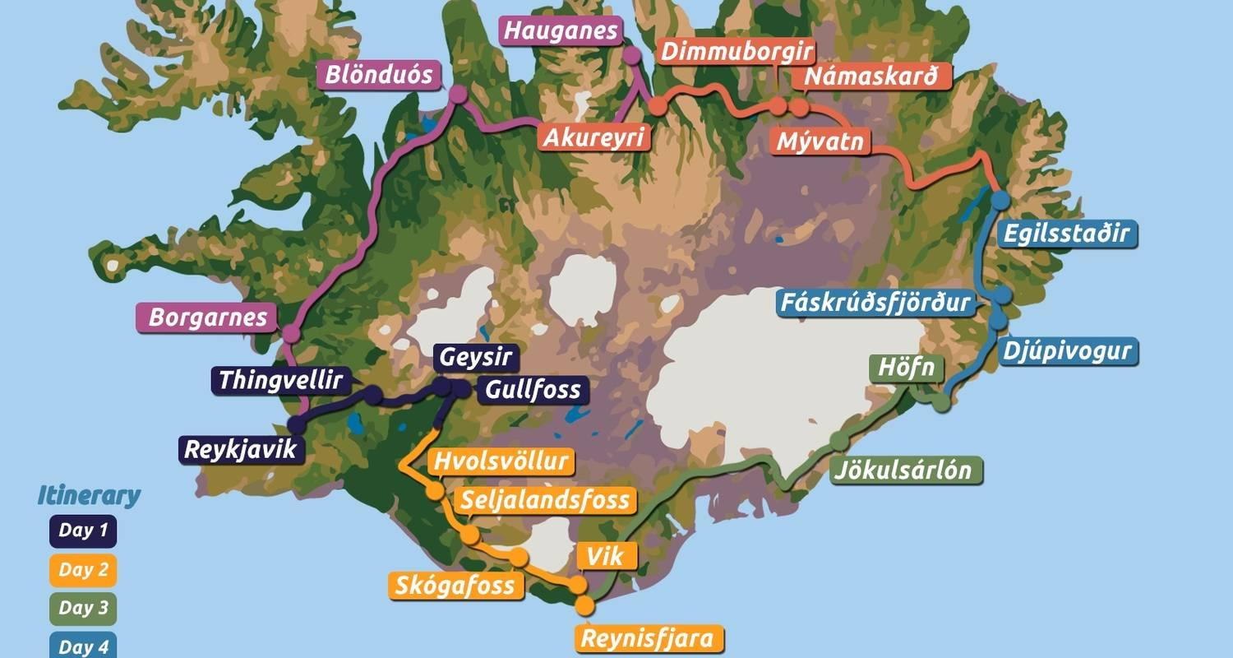

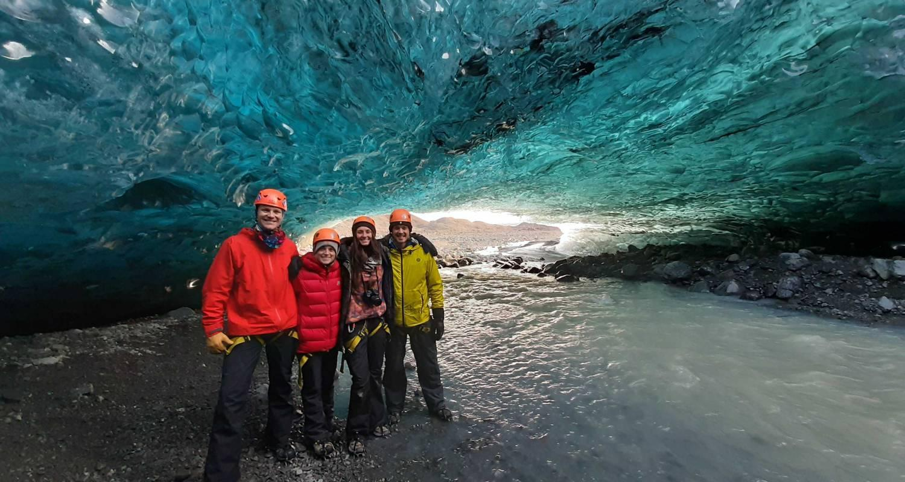

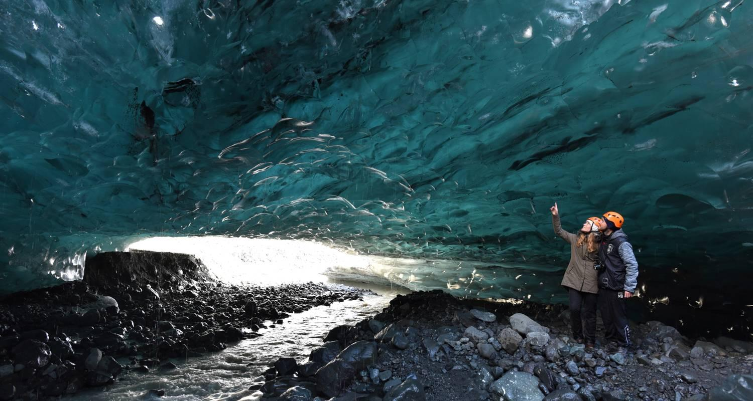

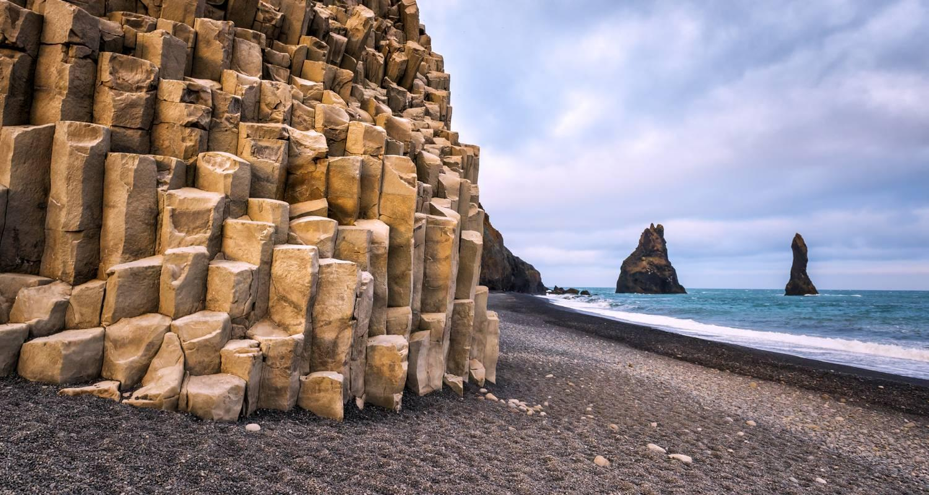

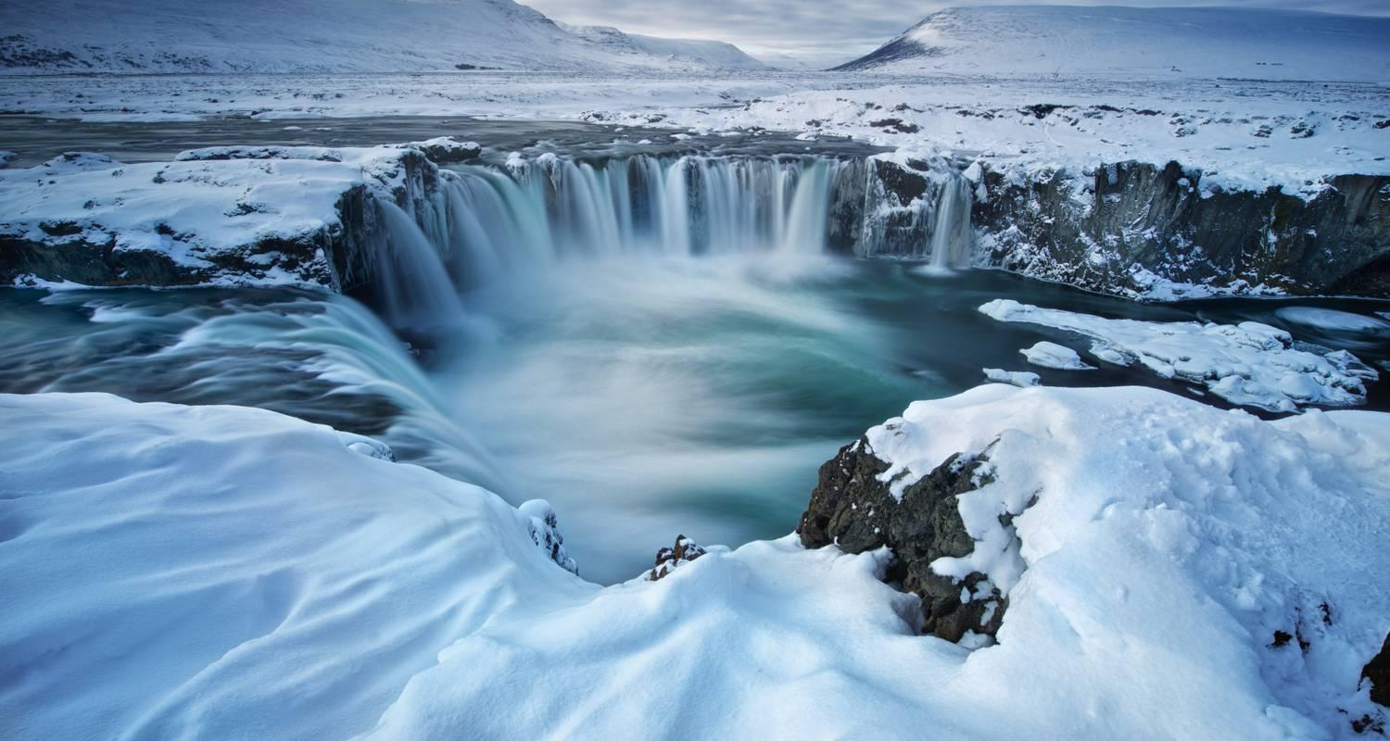

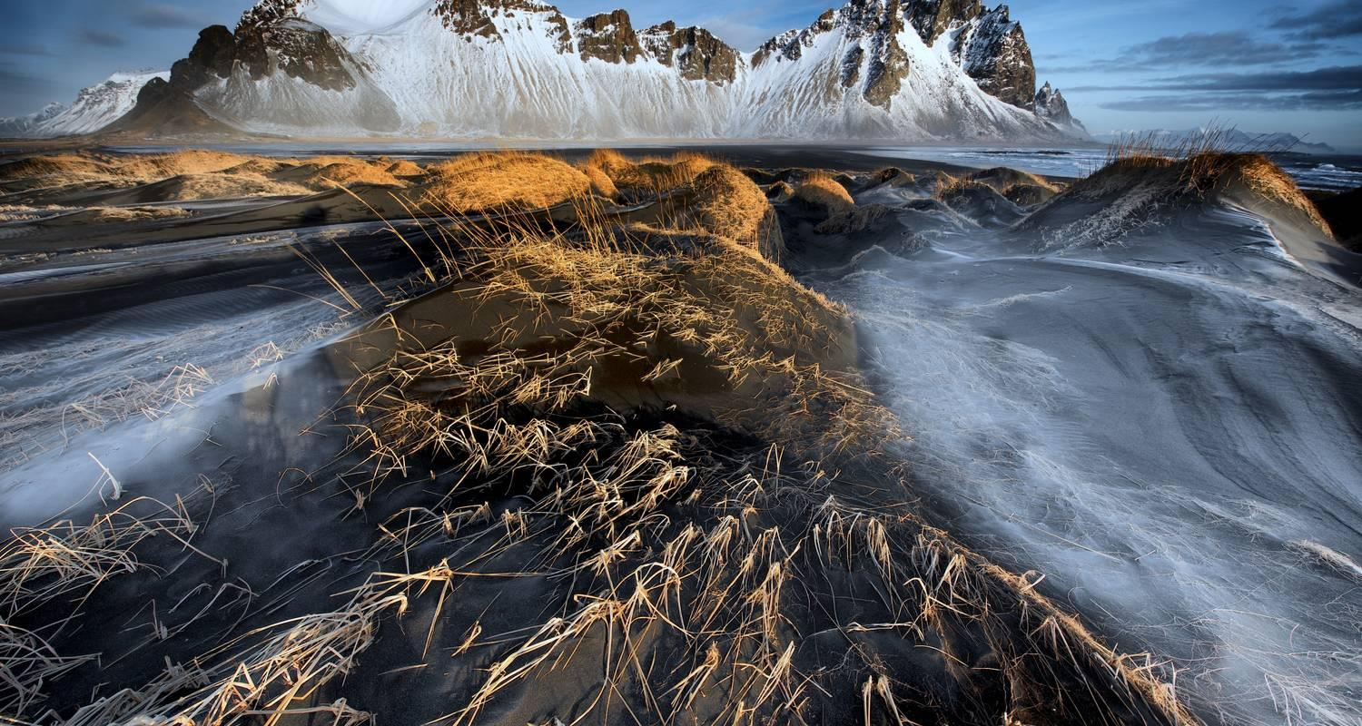

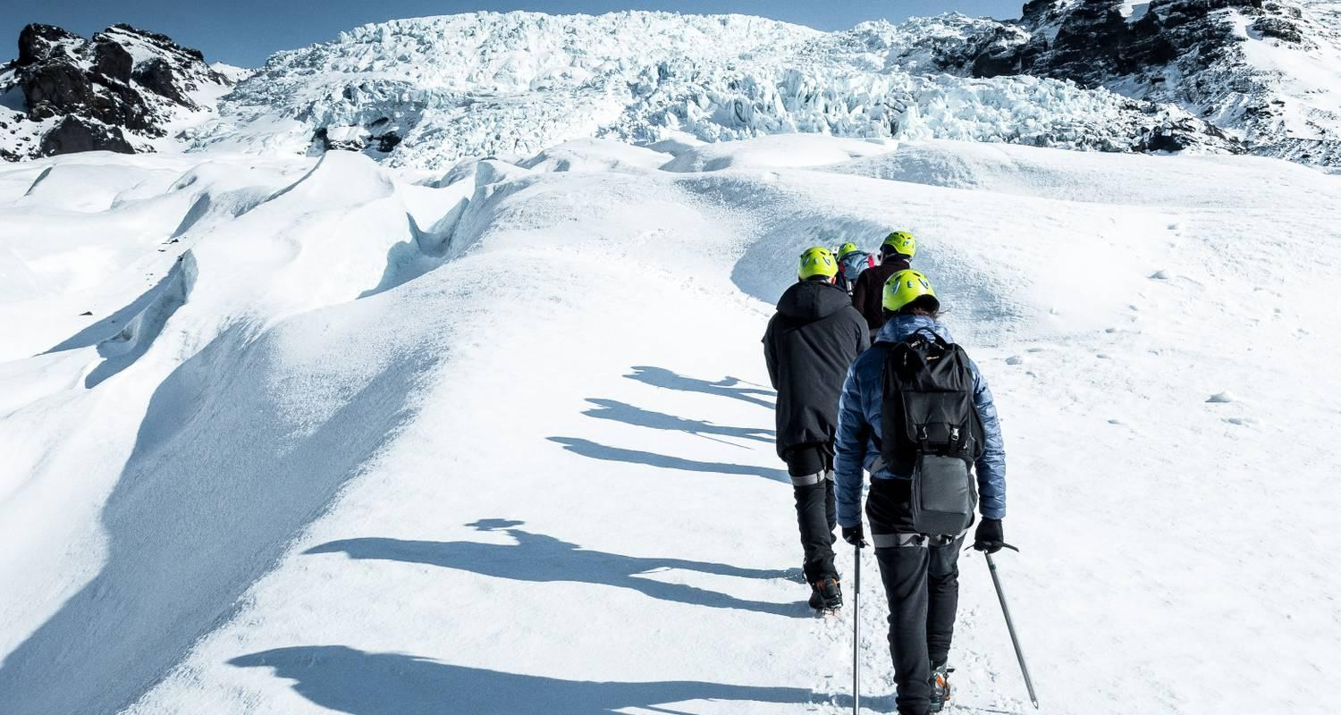



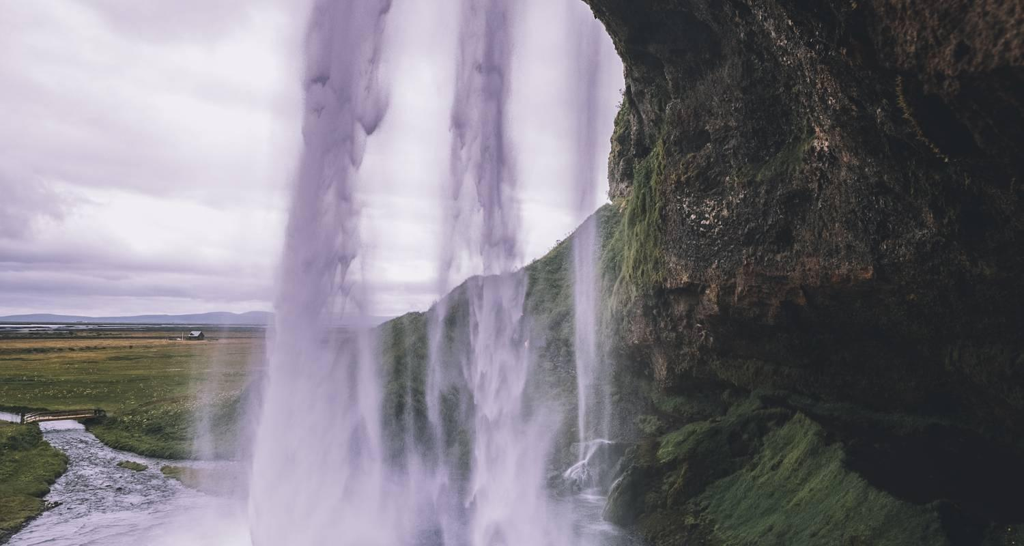

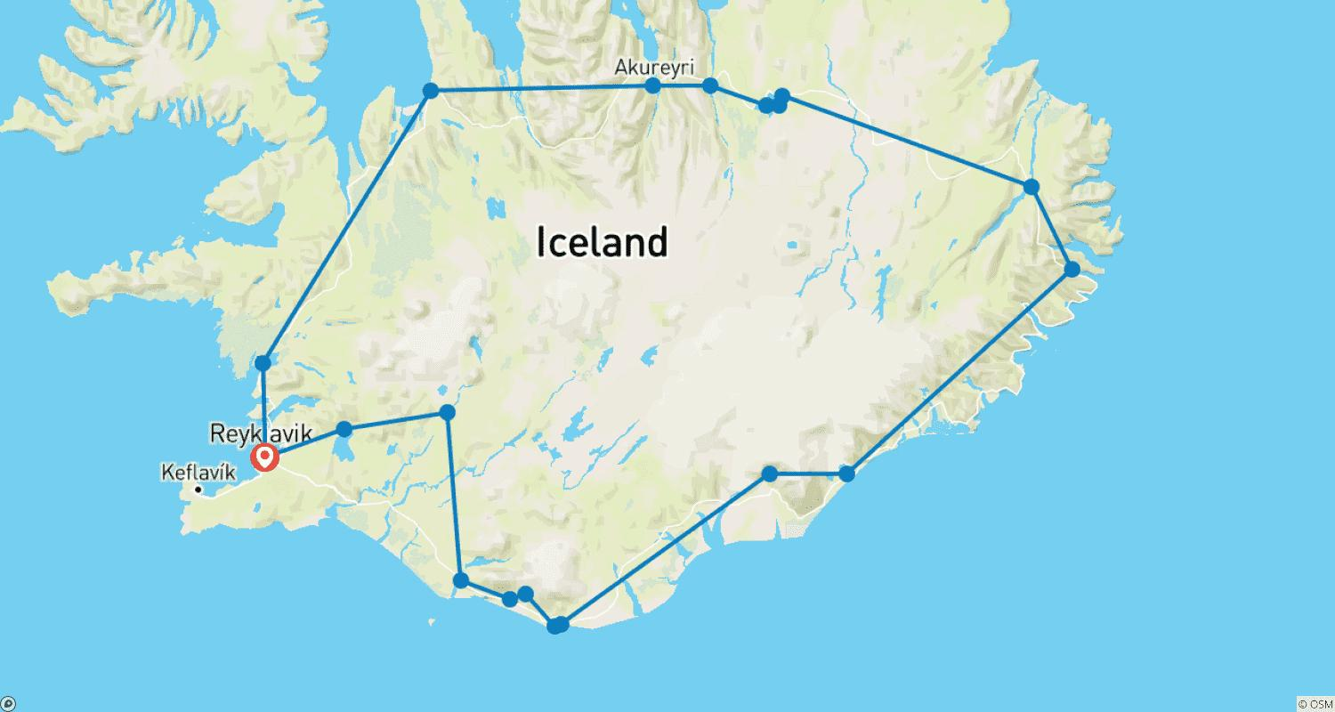

Tour ID: 182993  
Tour Name: 8 Day Around Iceland Winter Minibus Tour

Tour destinations: ['Reykjavik', 'Thingvellir National Park', 'Gullfoss', 'Geysir', 'Seljaland', 'Skogafoss', 'Solheimajokull', 'Reynisfjara', 'Vik', 'Skaftafell', 'Jokulsarlon', 'Djupivogur', 'Faskrudsfjordur', 'Egilsstadir', 'Mount Namaskard', 'Myvatn', 'Dimmuborgir', 'Hverfjall Volcano', 'Akureyri', 'Blonduos', 'Borgarnes', 'Snaefellsjokull National Park', 'Arnarstapi', 'Djupalonssandur', 'Kirkjufell Mountain', 'Stykkisholmur', 'Reykholt', 'Hraunfossar']

Tour destinations images:



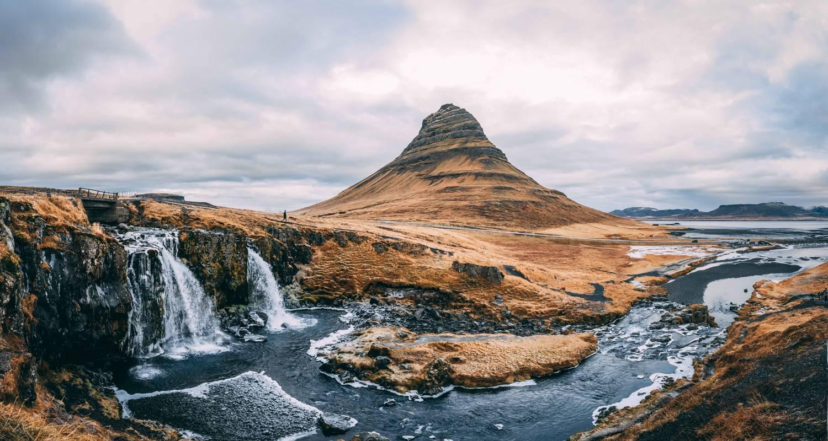

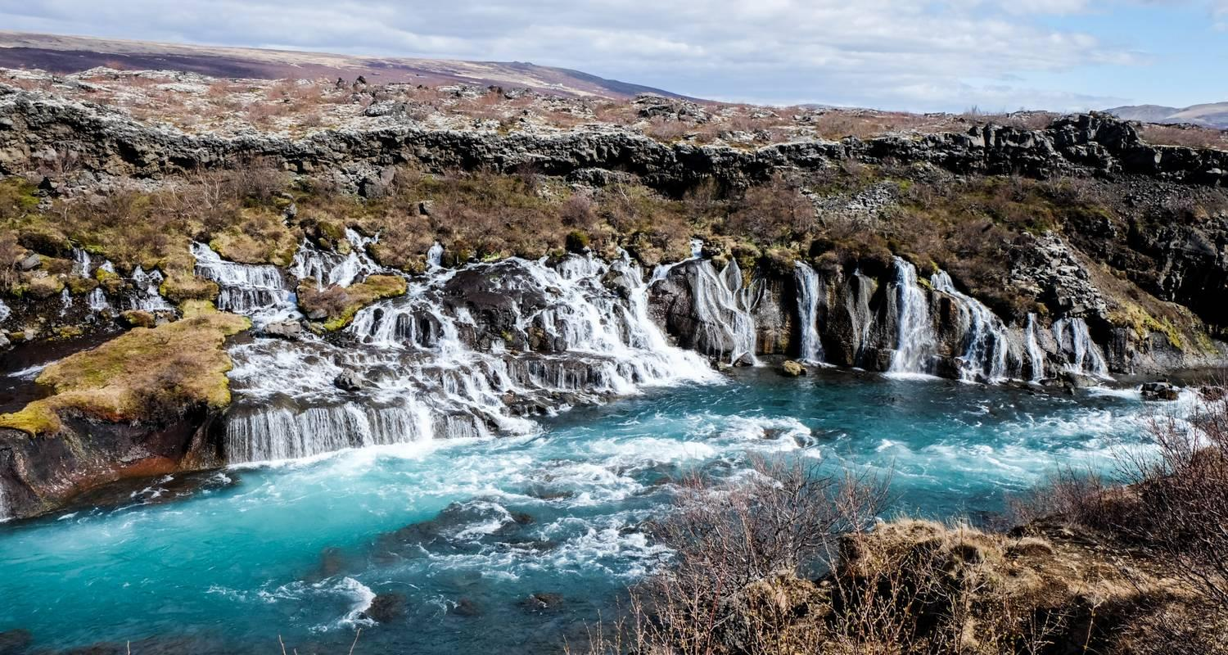



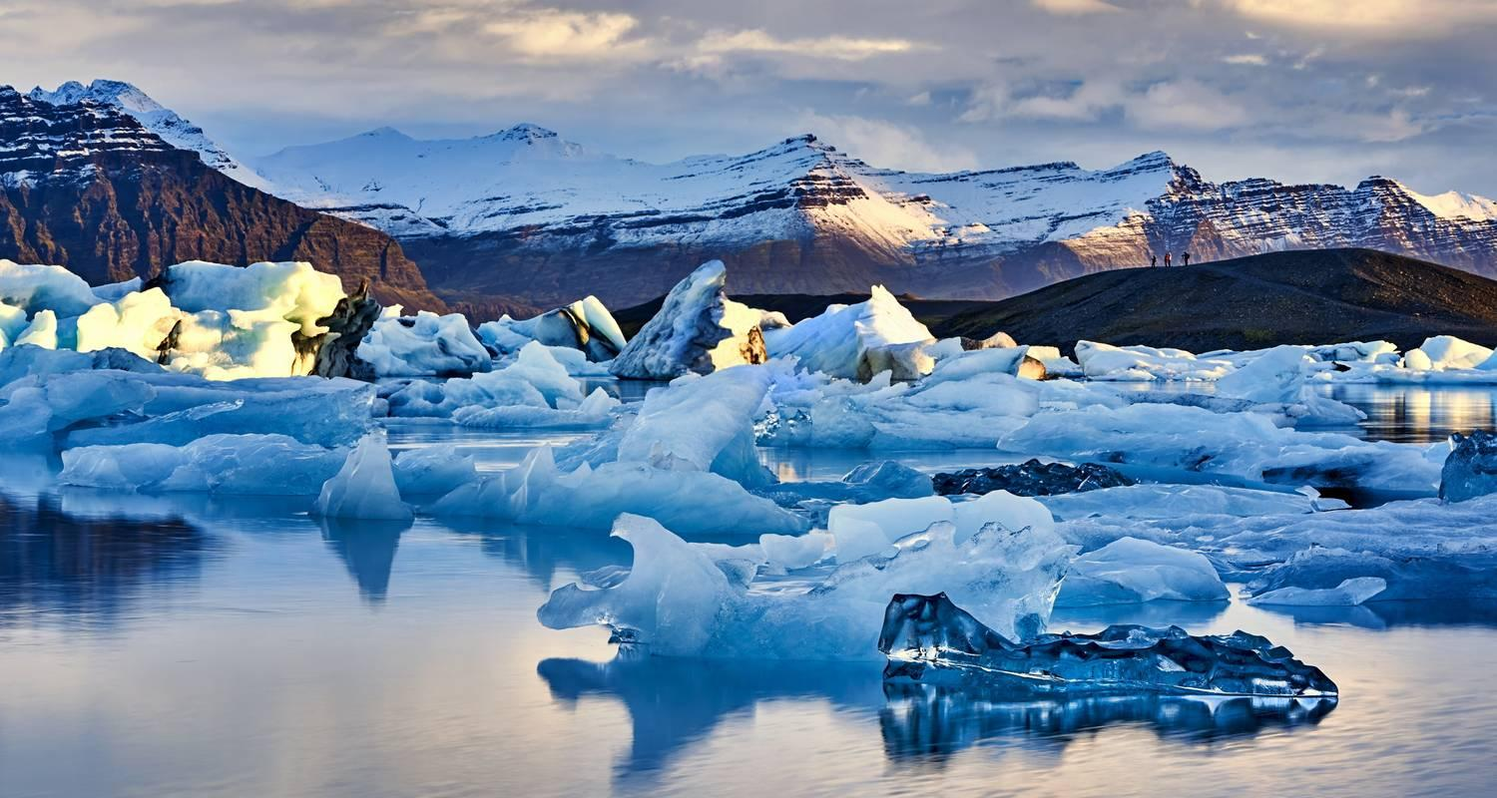

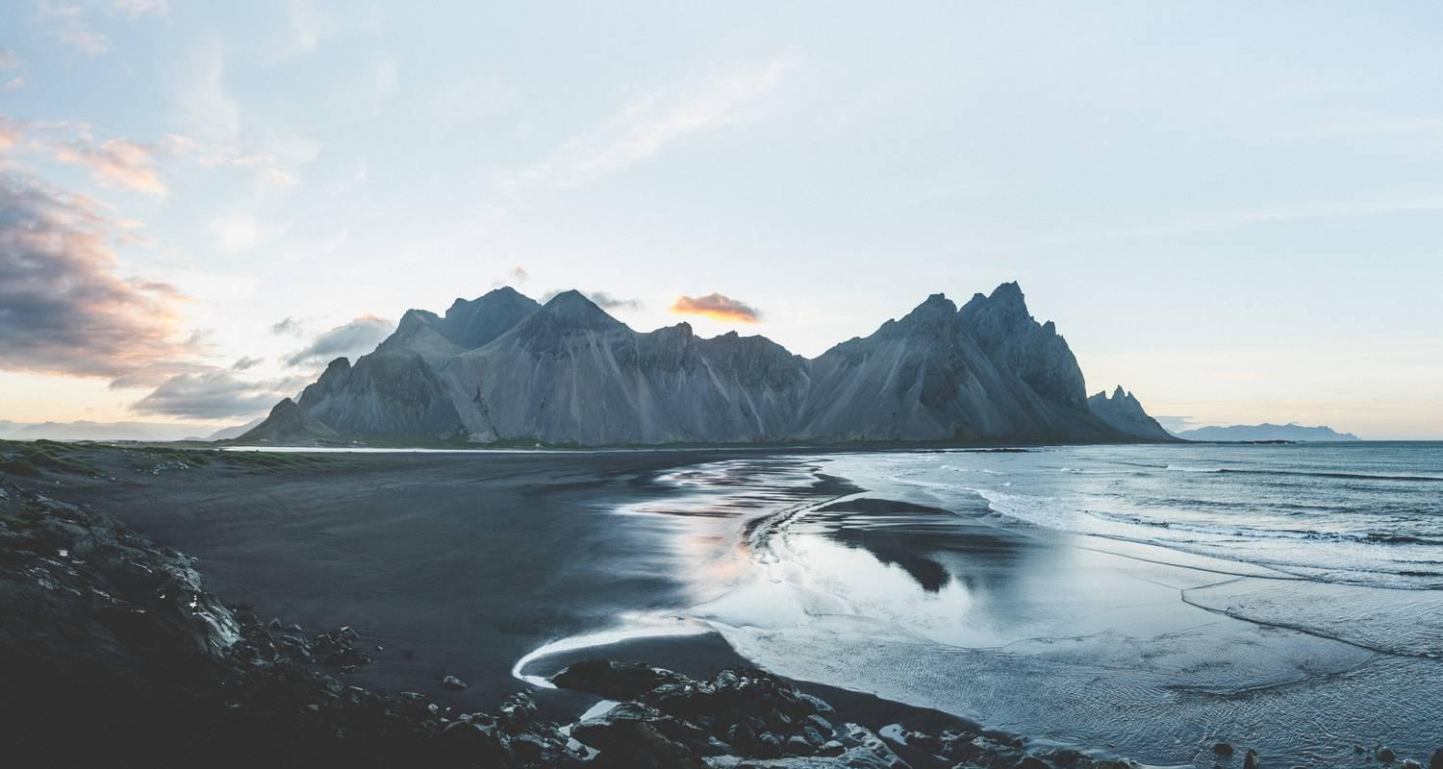



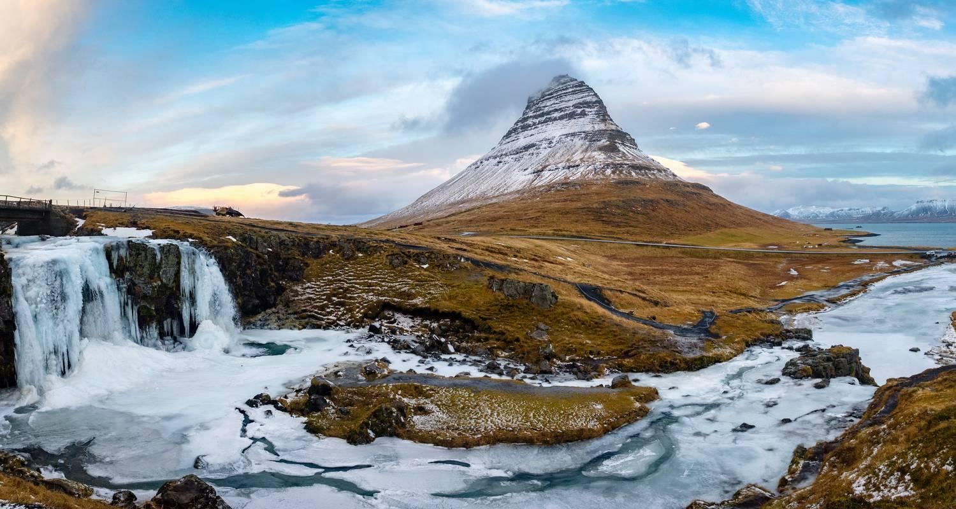

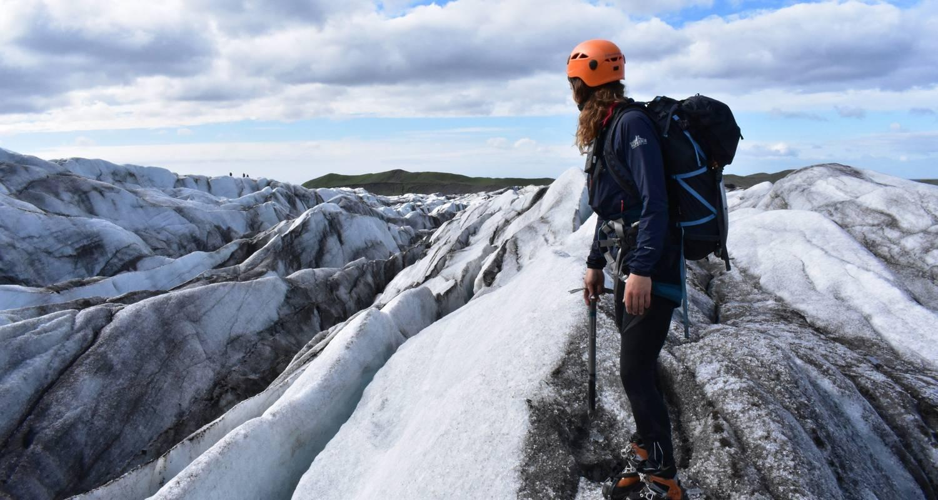

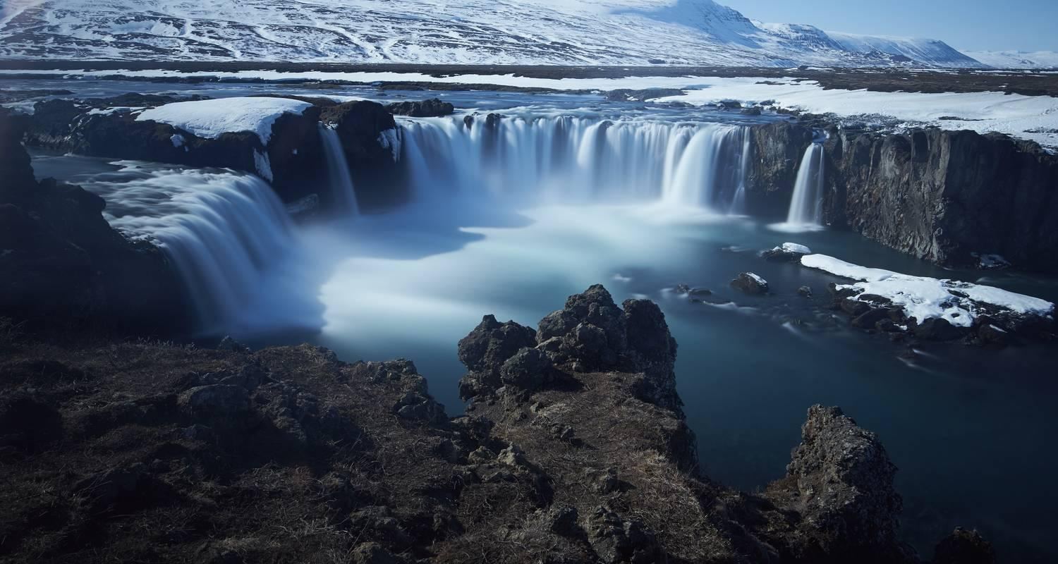

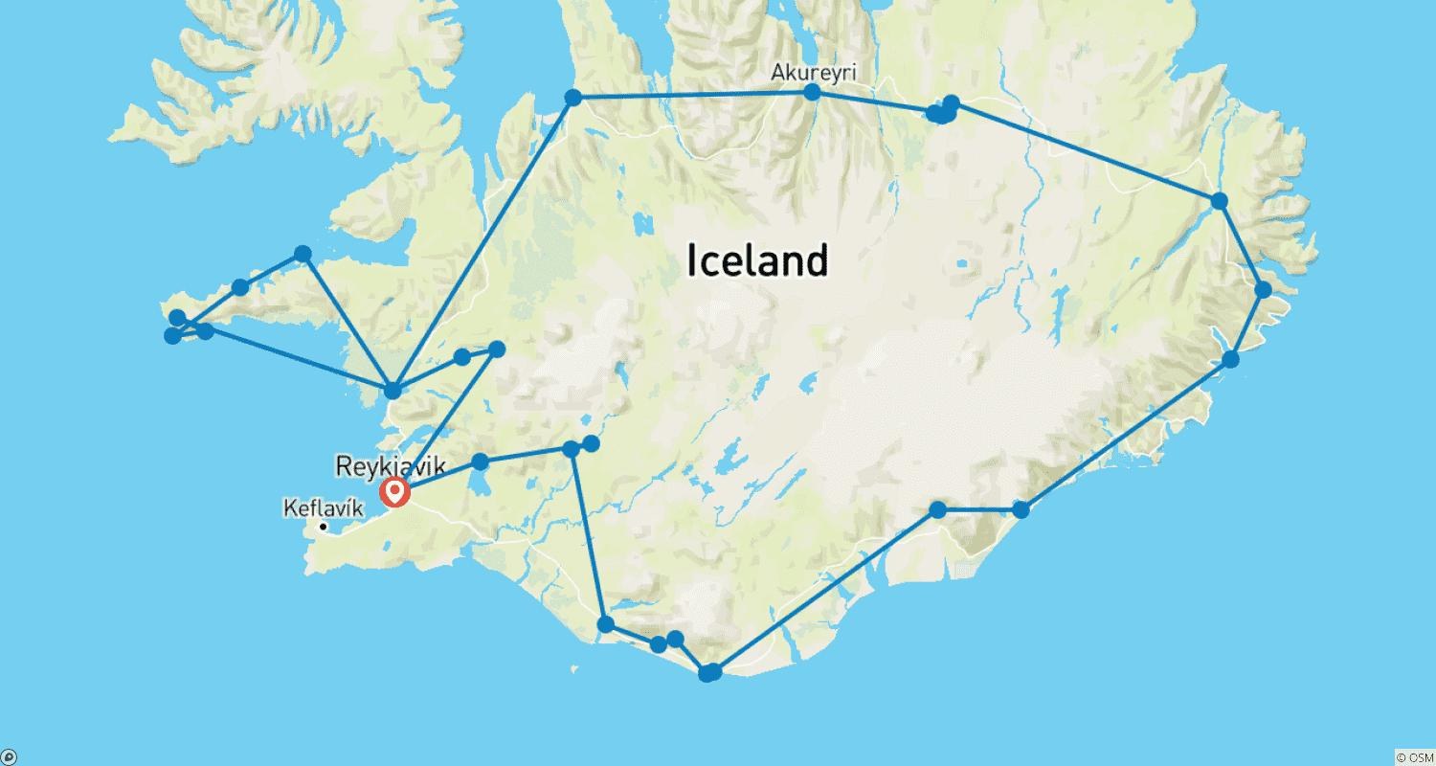

Tour ID: 188765  
Tour Name: Iceland – The Land of Fire & Ice

Tour destinations: ['Reykjavik', 'Borgarnes', 'Thingvellir National Park', 'Blue Lagoon']

Tour destinations images:

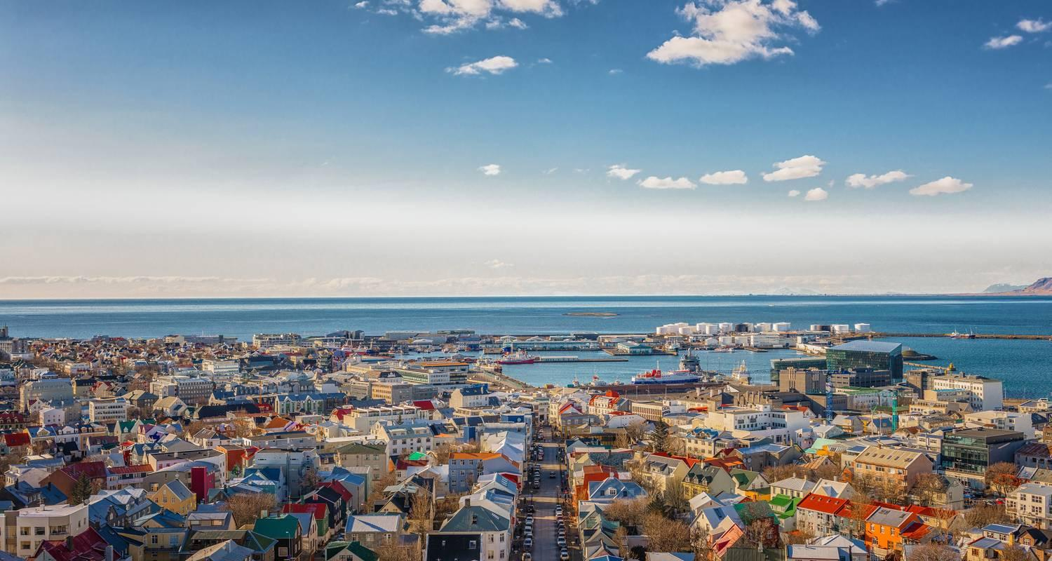

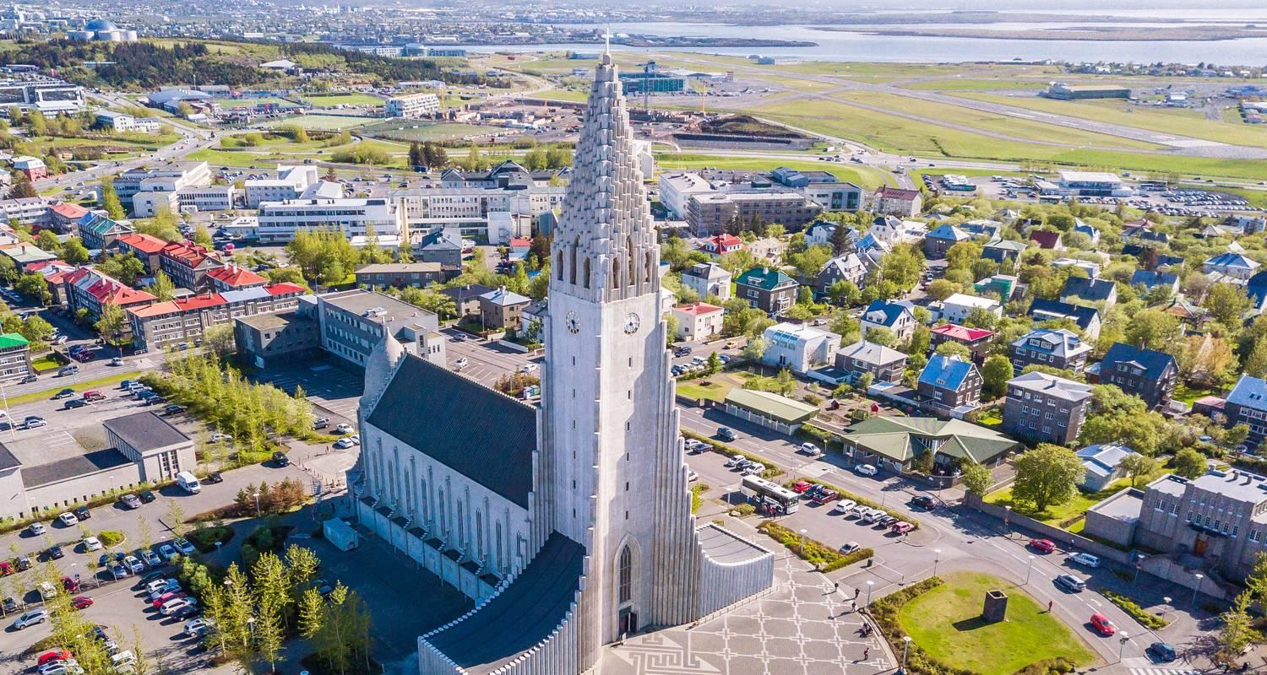

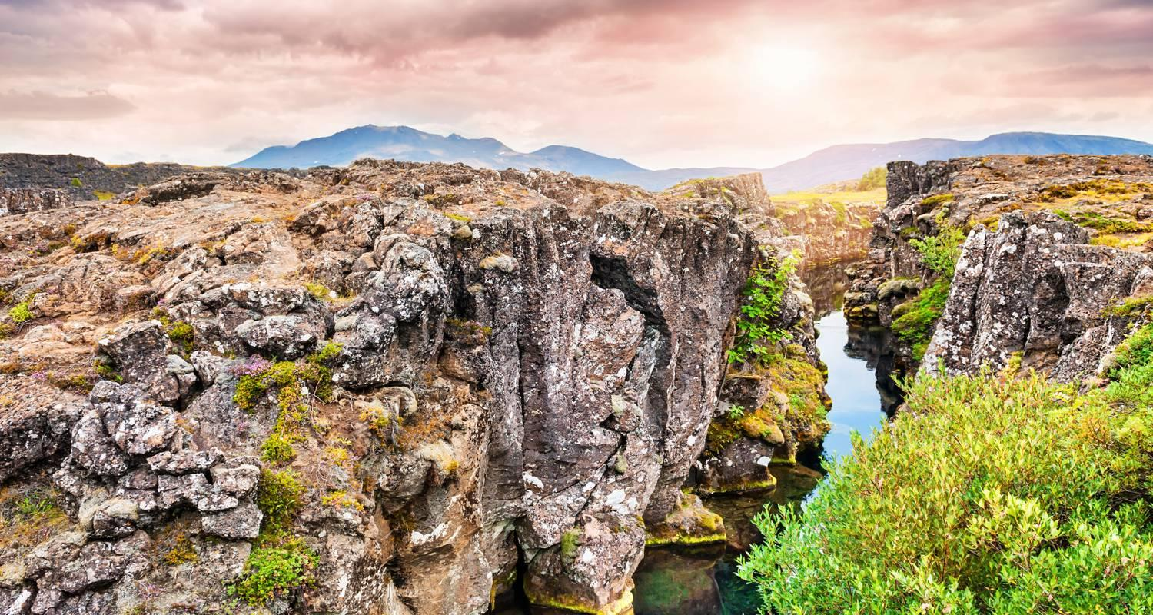

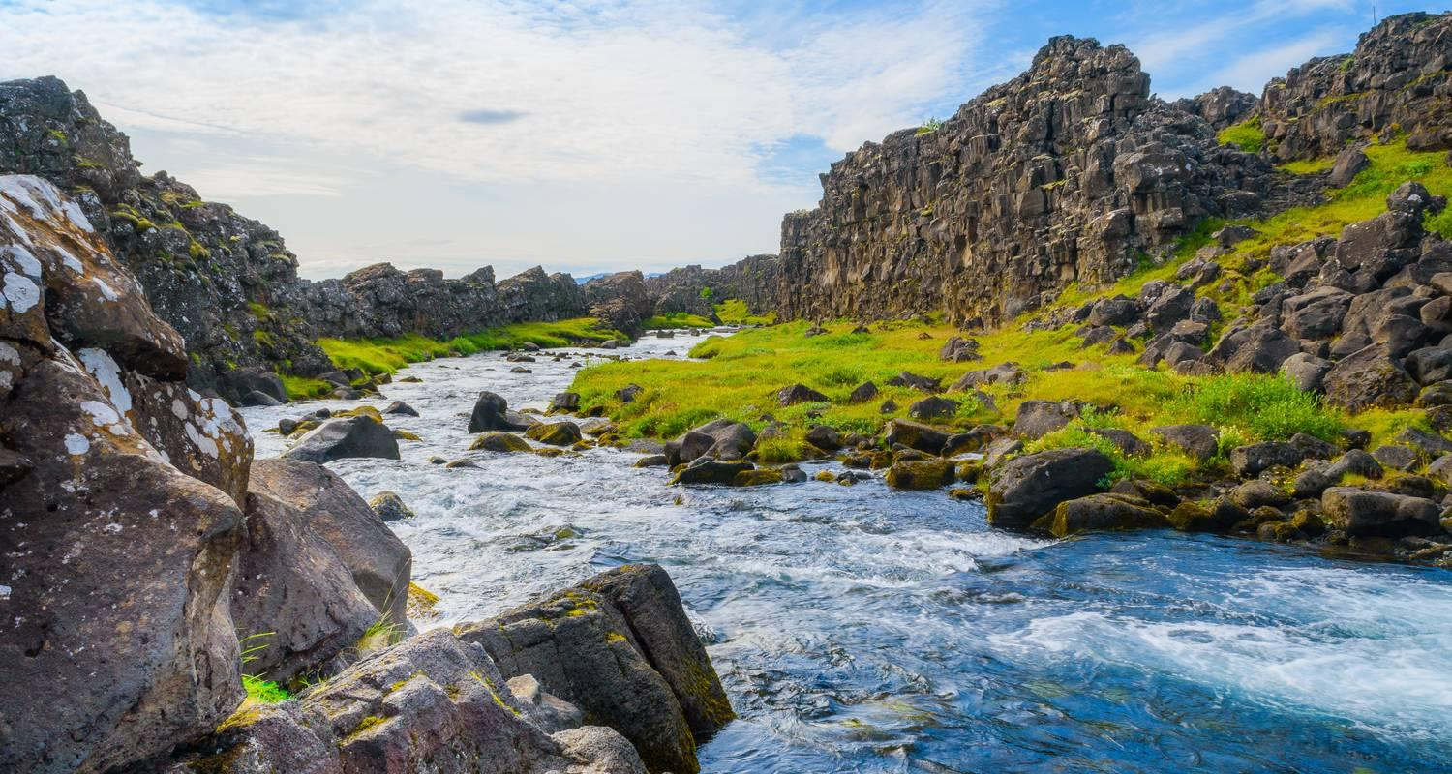

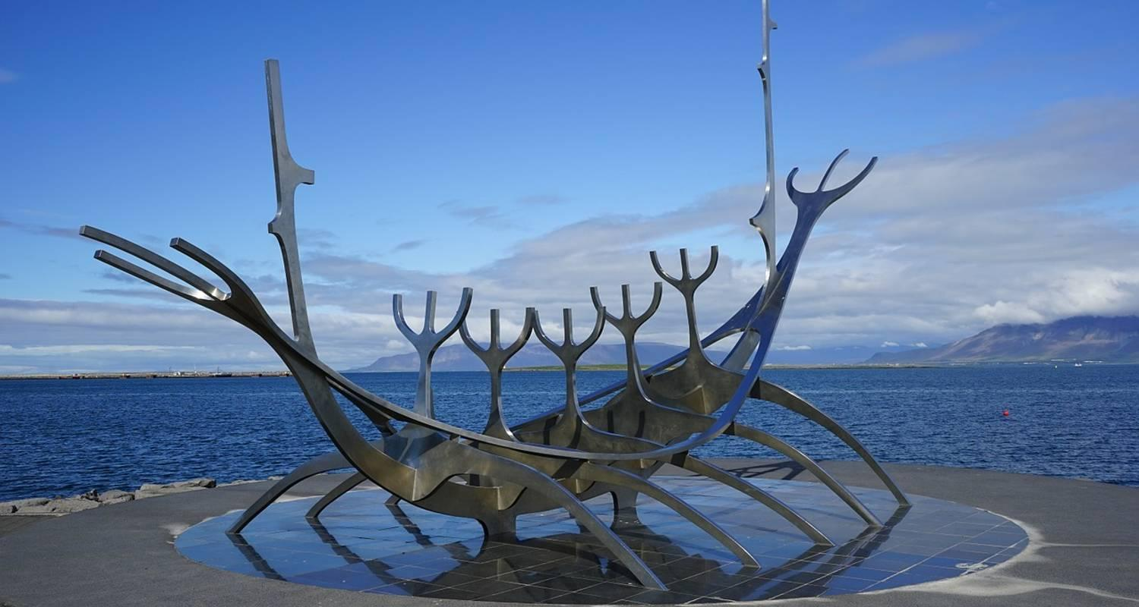

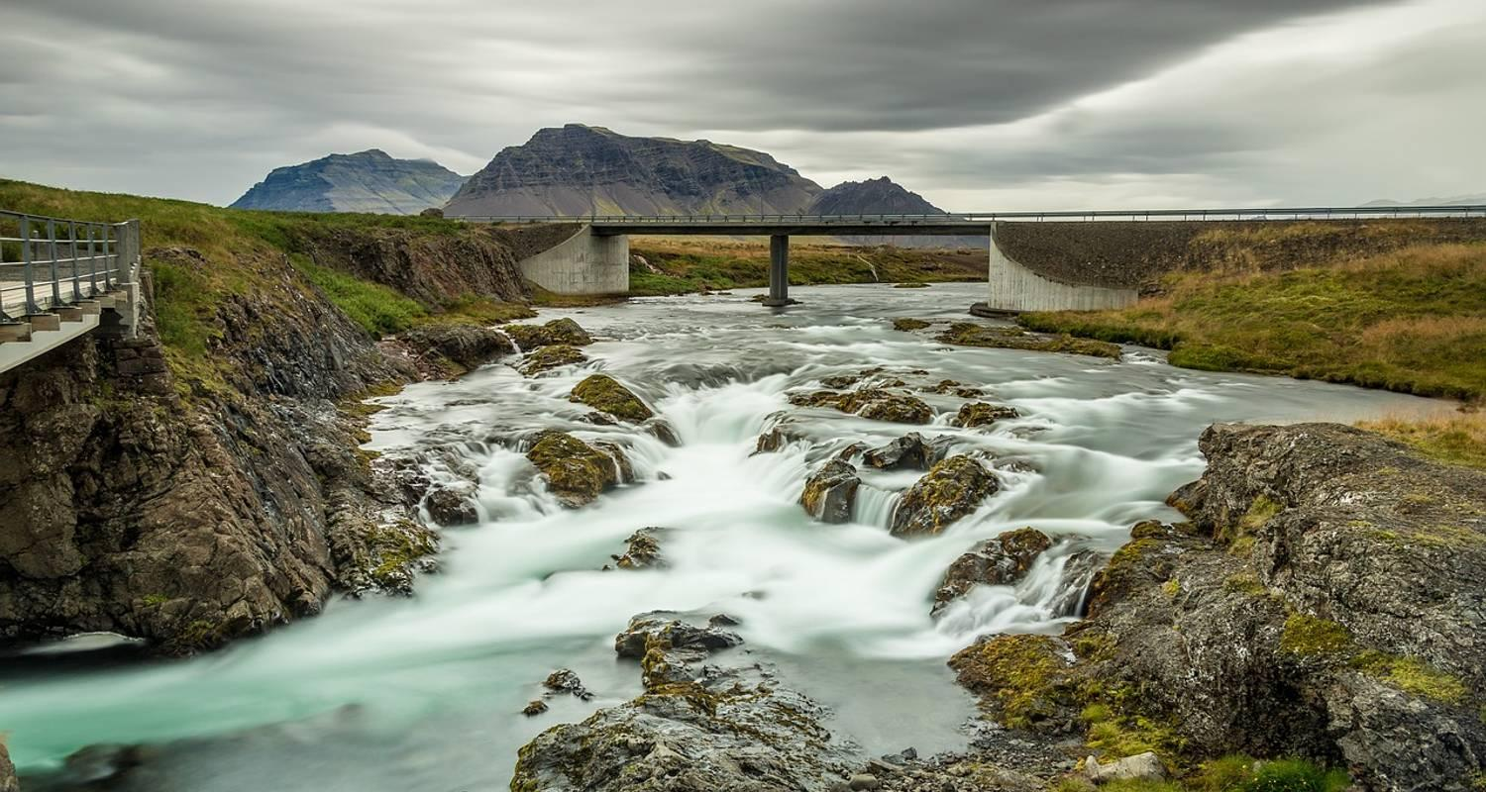

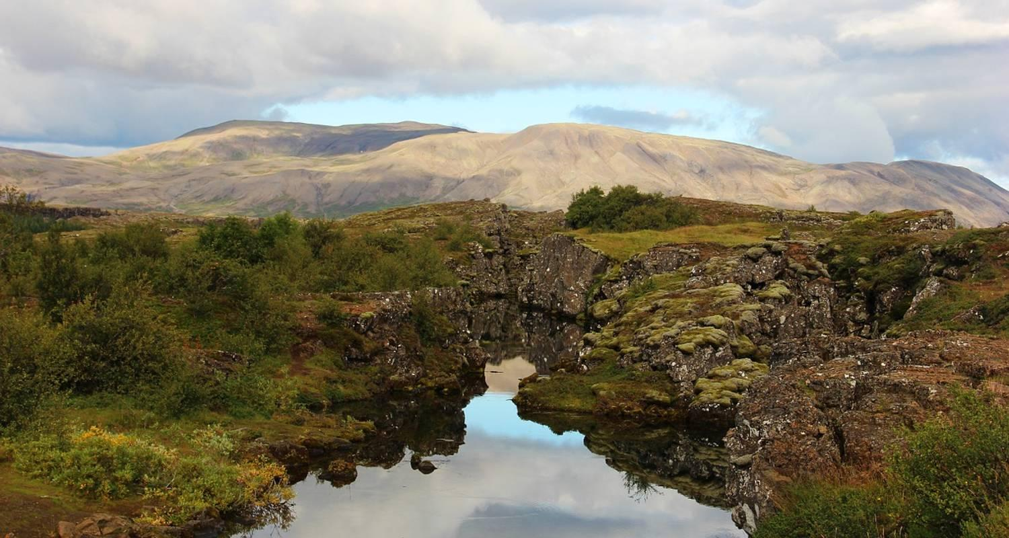

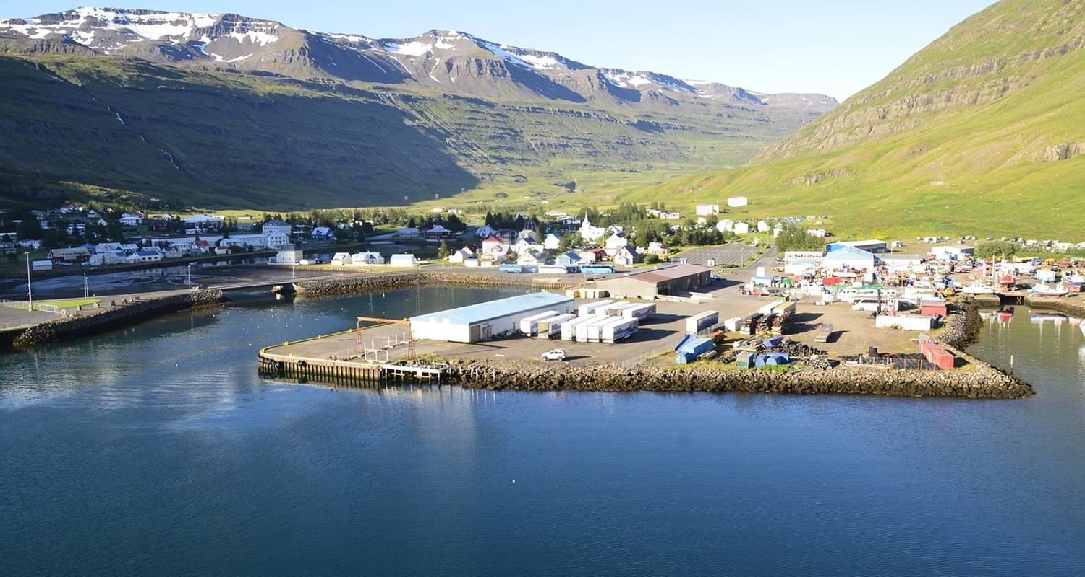

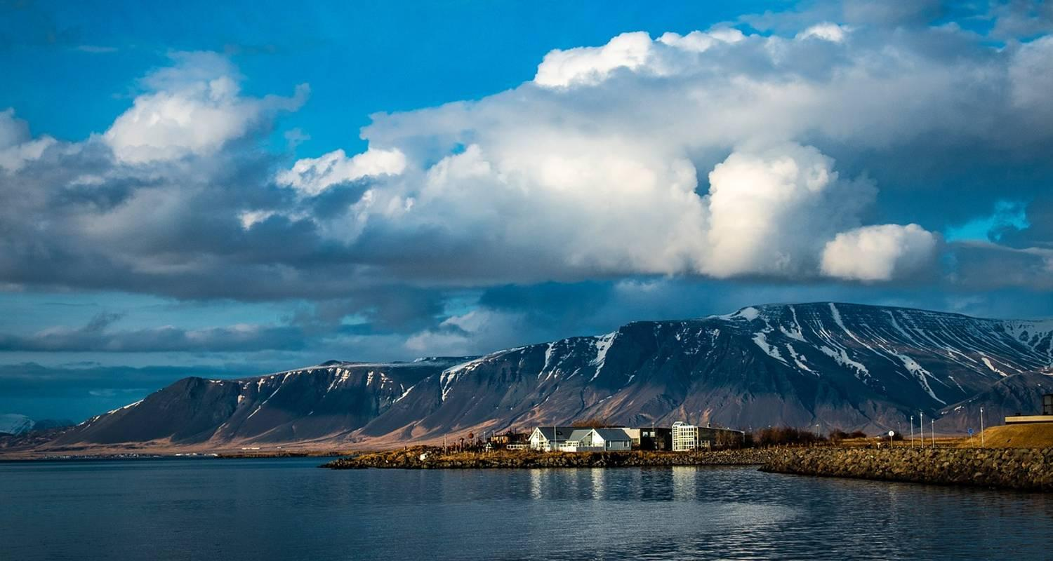

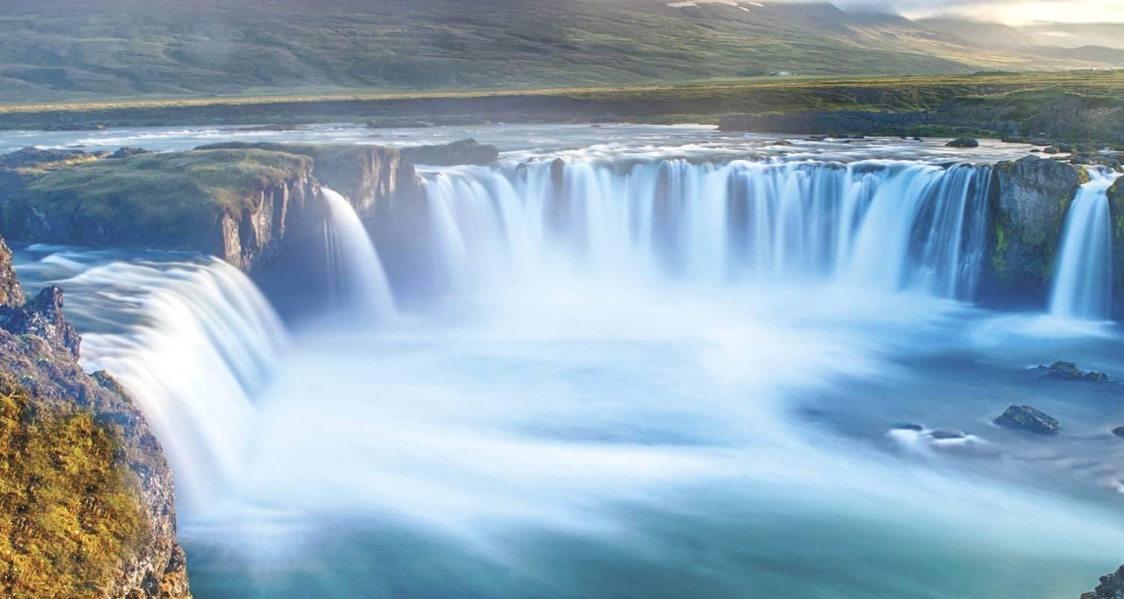

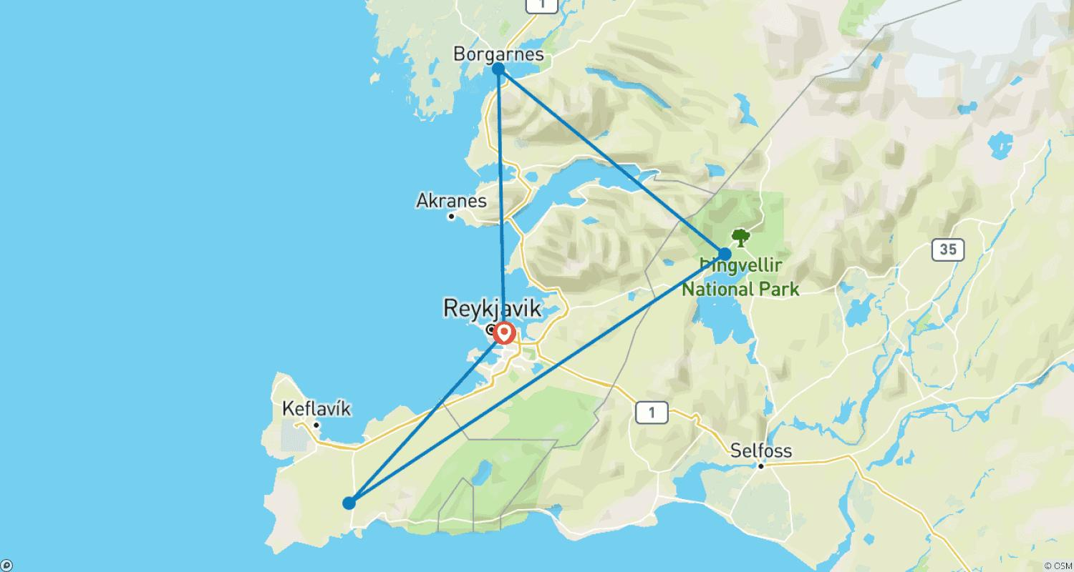

Tour ID: 192496  
Tour Name: Natural Wonders of Iceland (Small Groups, 9 Days)

Tour destinations: ['Reykjavik', 'Vik', 'Hofn', 'Egilsstadir', 'Akureyri', 'Borgarnes', 'Snaefellsjokull National Park', 'Thingvellir National Park']

Tour destinations images:

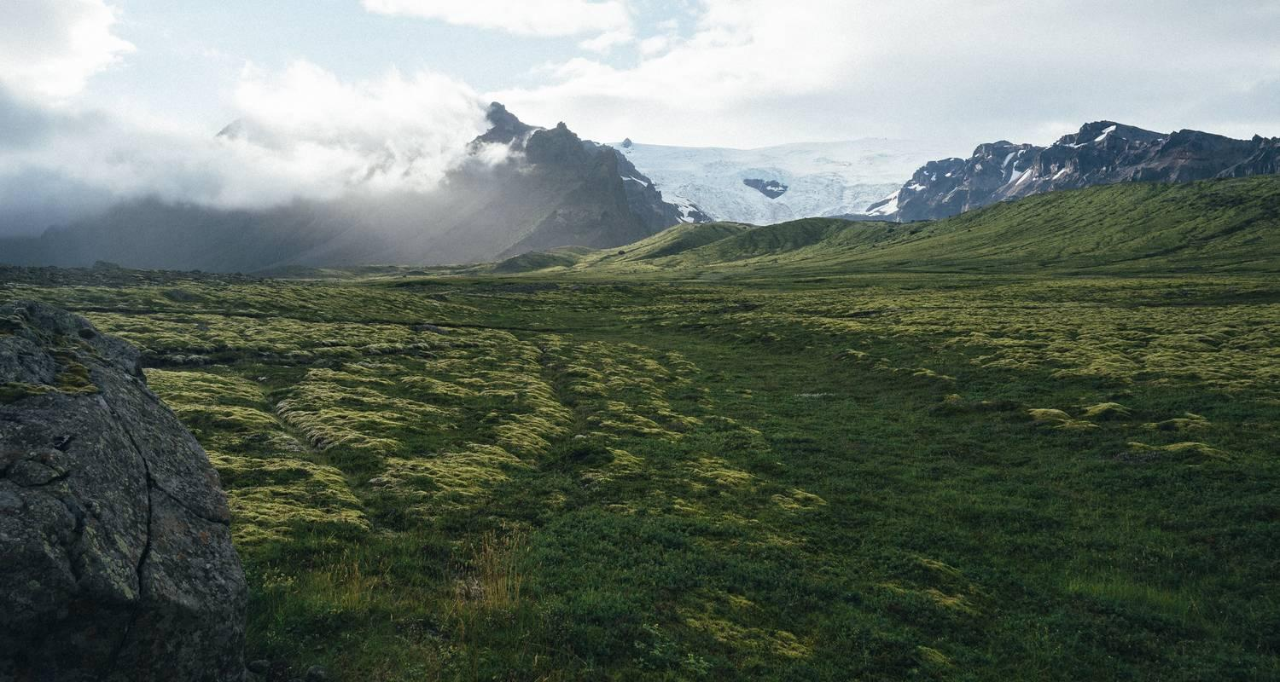

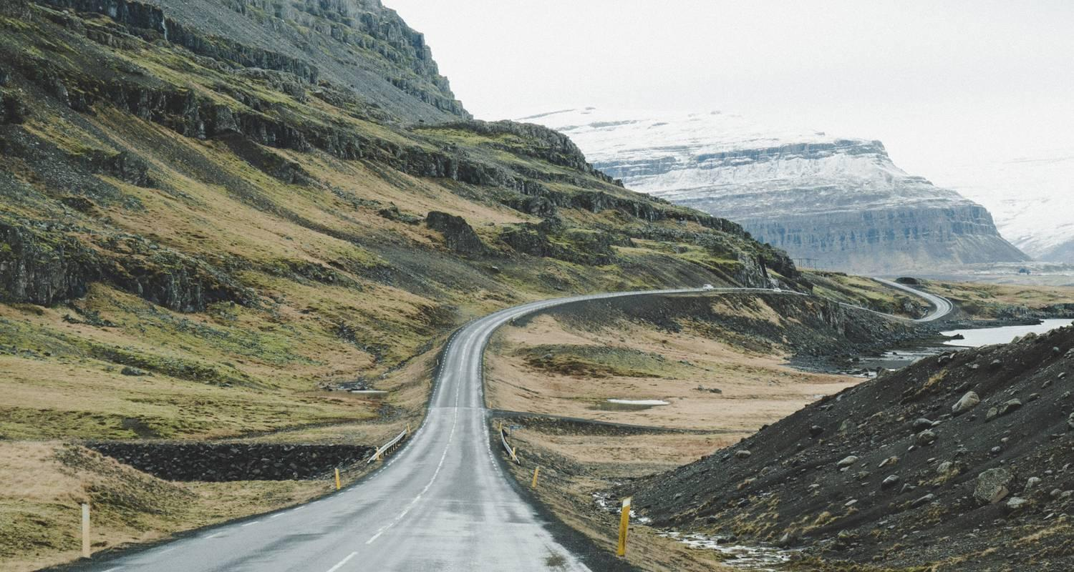

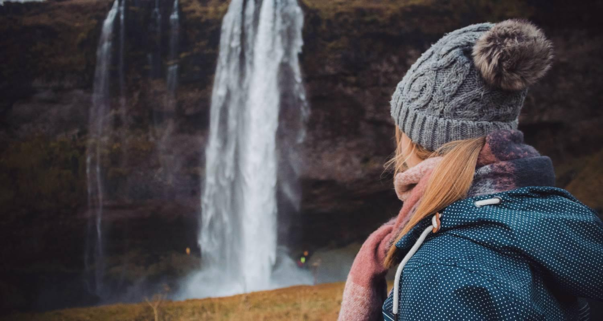

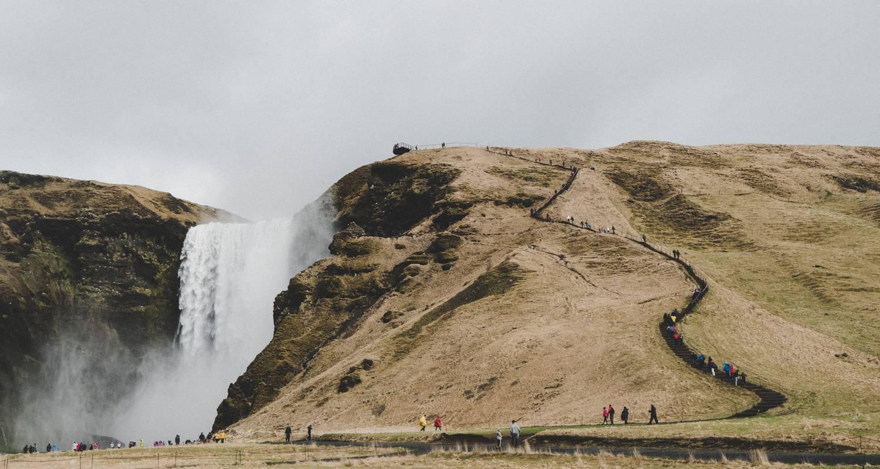

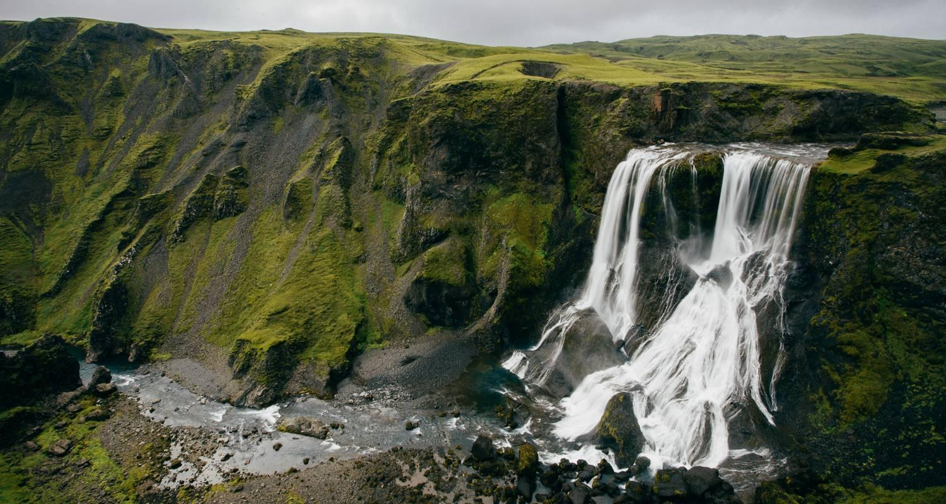

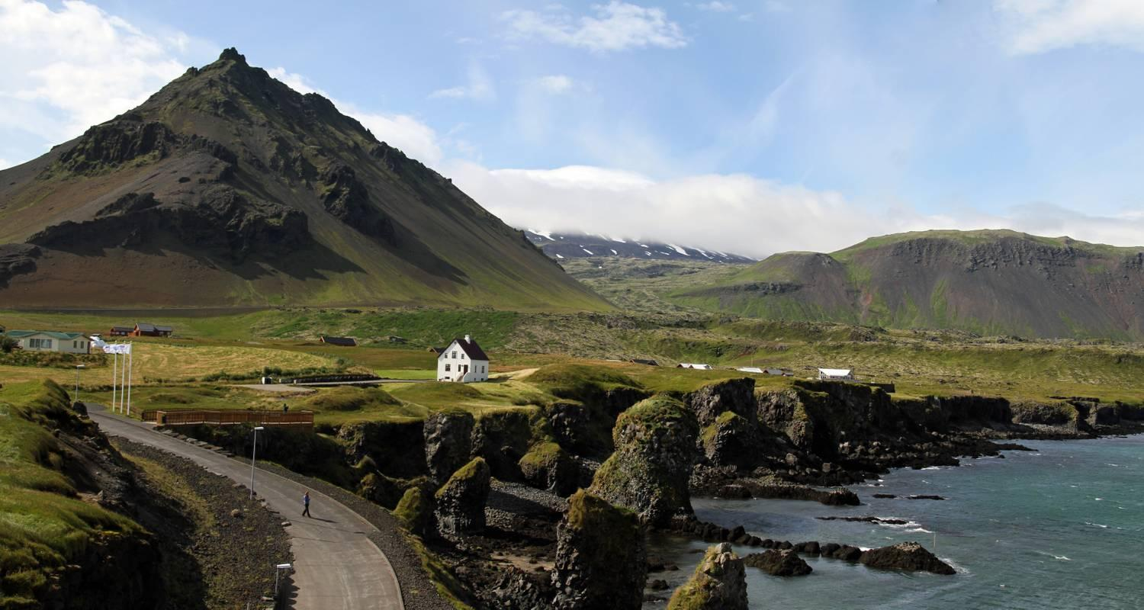

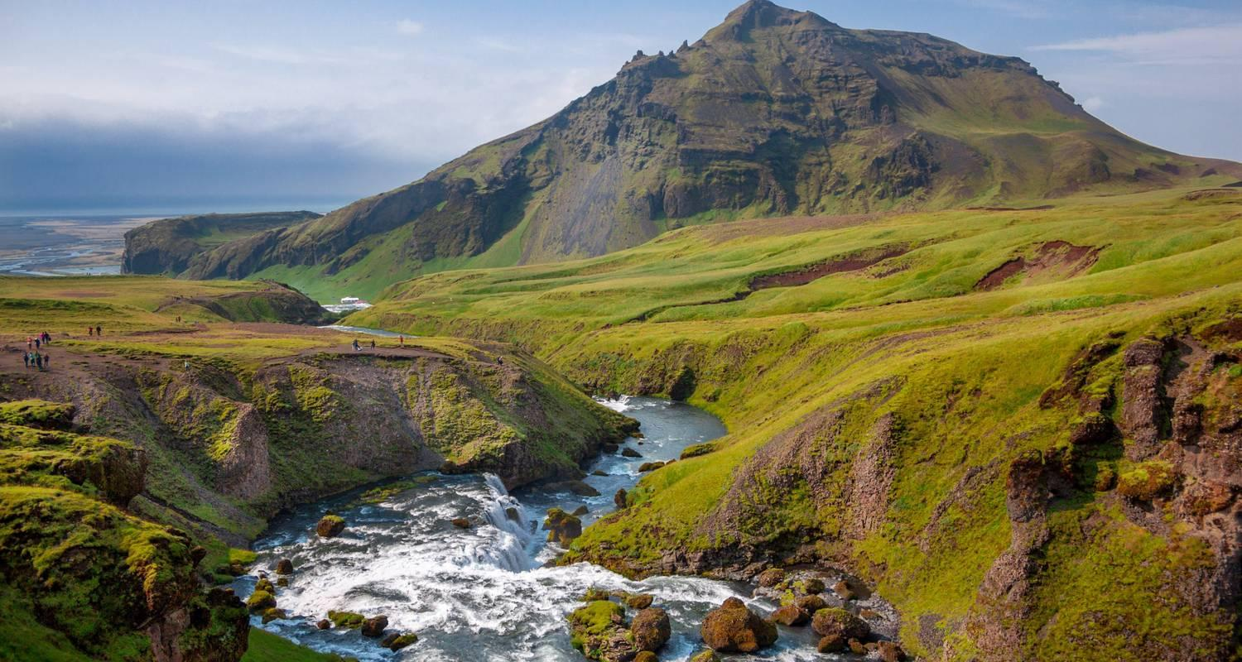

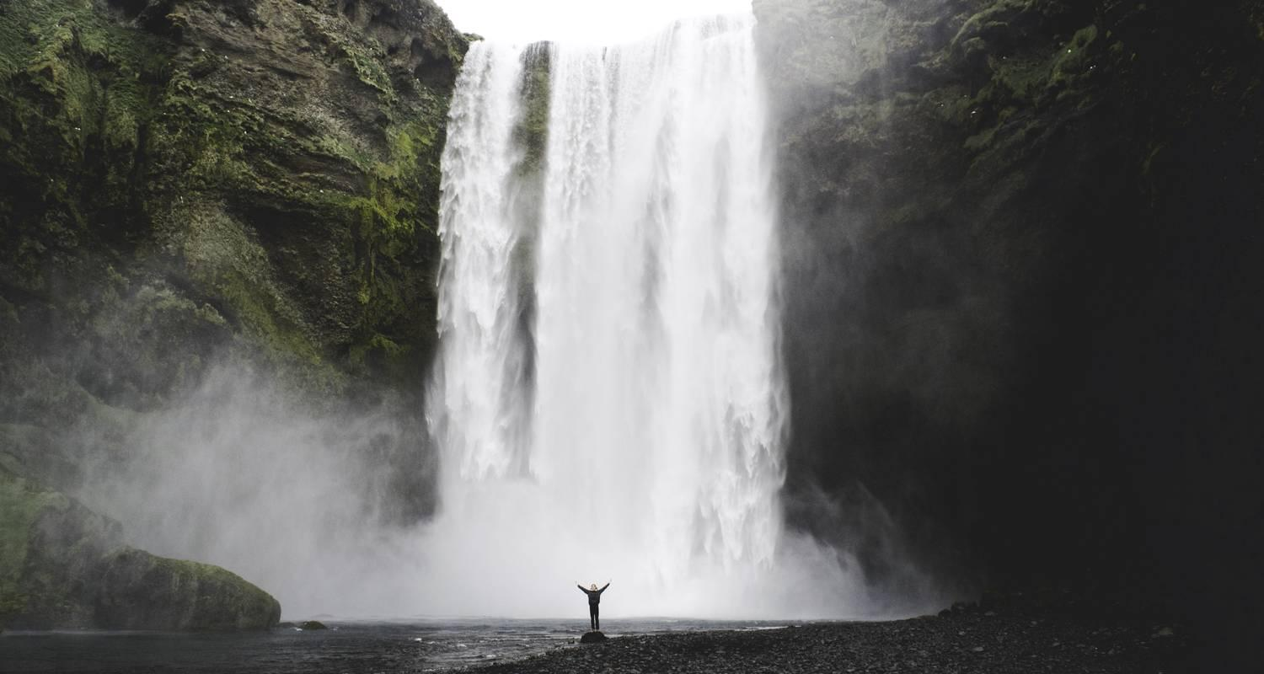

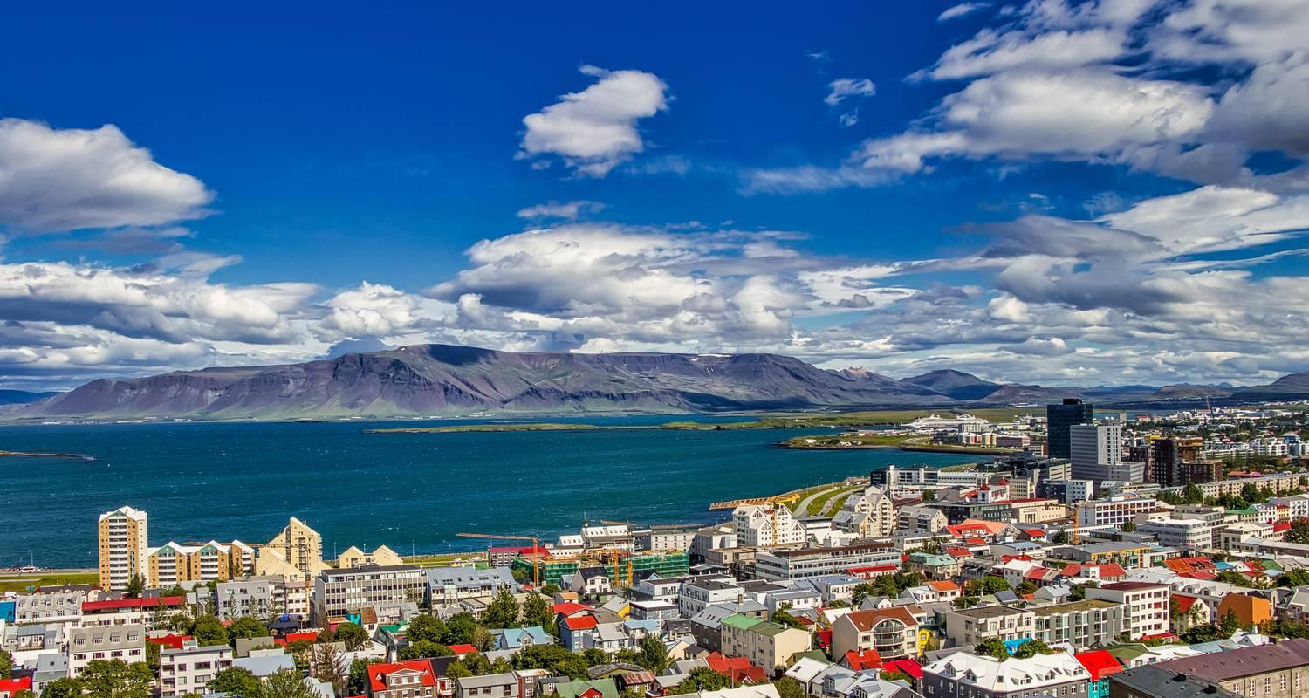

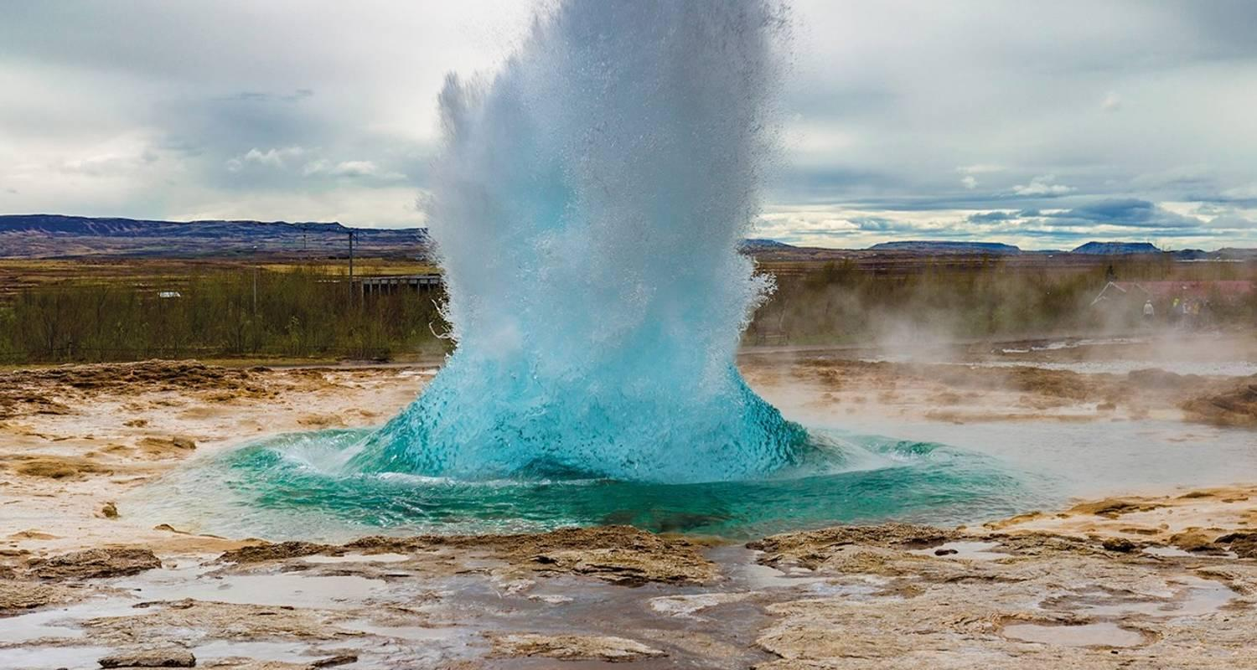

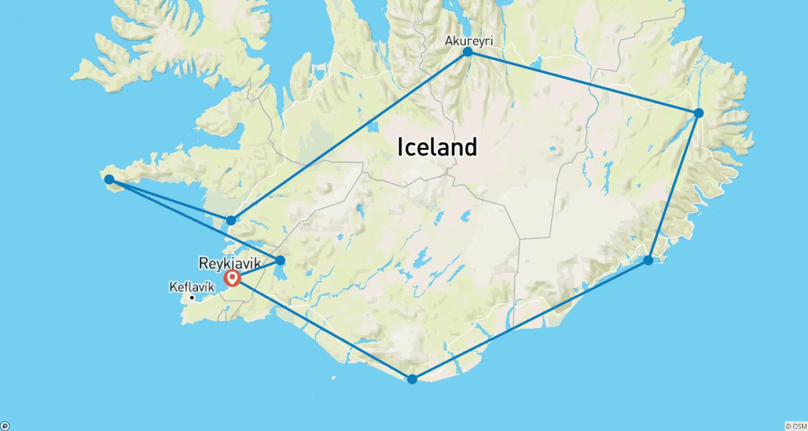

Tour ID: 194228  
Tour Name: 3 Day South Iceland Tour - Private Tour

Tour destinations: ['Reykjavik', 'Thingvellir National Park', 'Geysir', 'Gullfoss', 'Fludir', 'Seljaland', 'Skogafoss', 'Solheimajokull', 'Reynisfjara', 'Skaftafell', 'Jokulsarlon']

Tour destinations images:

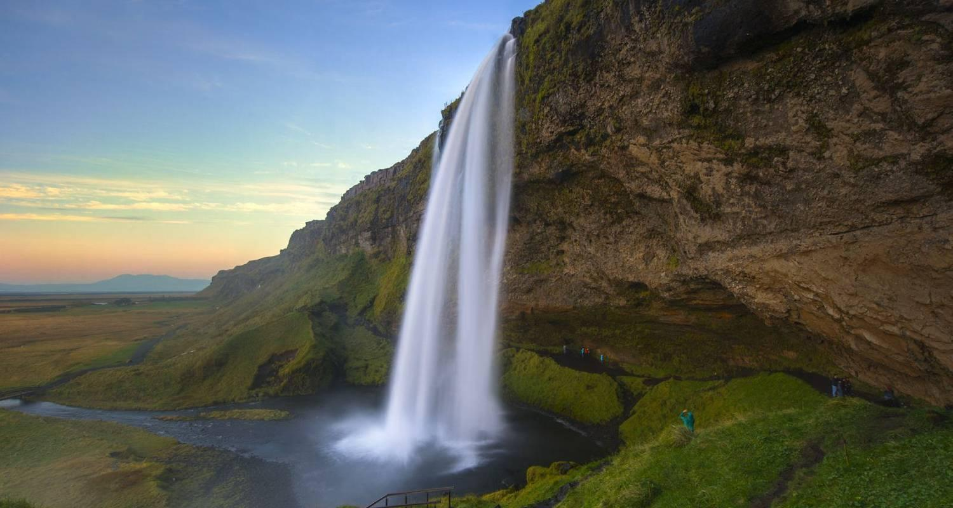

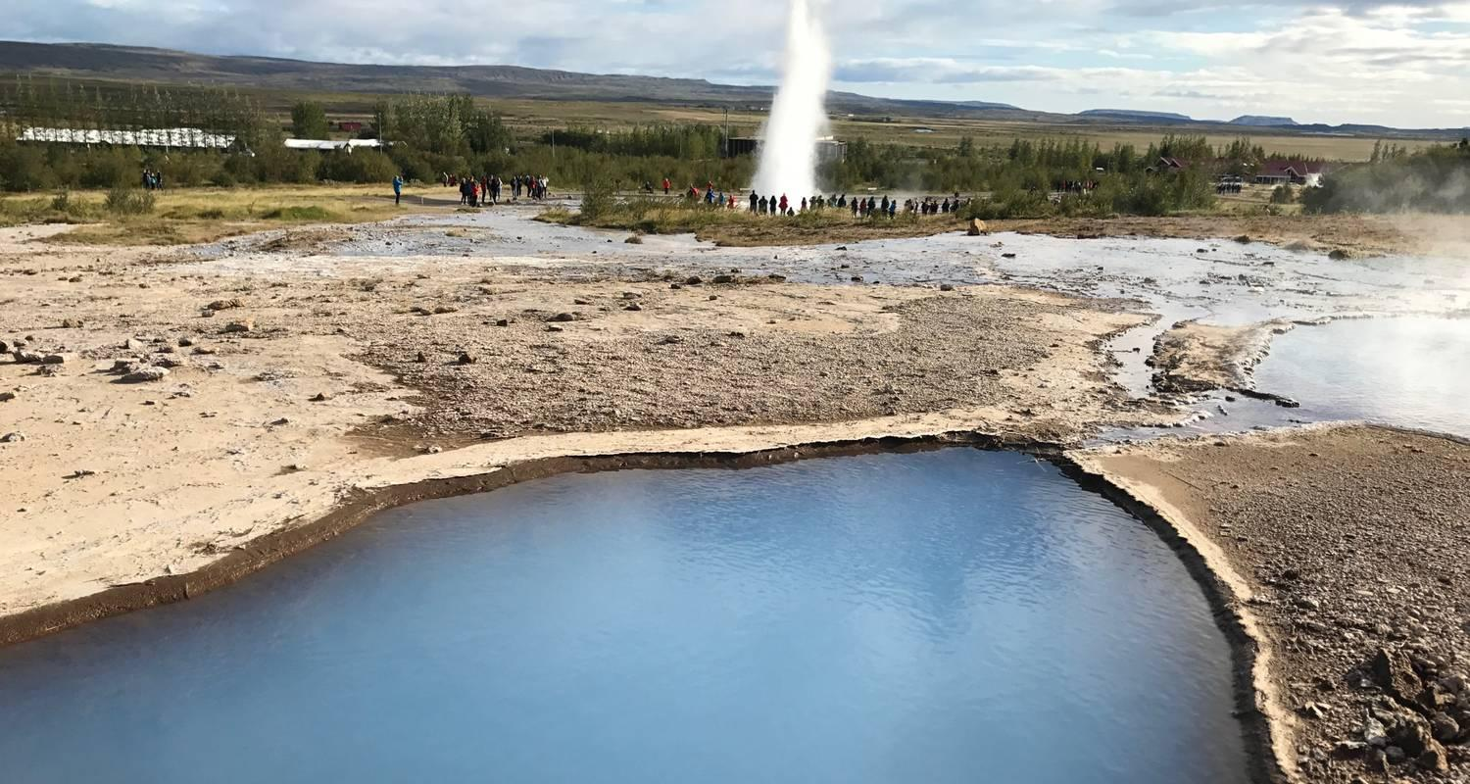

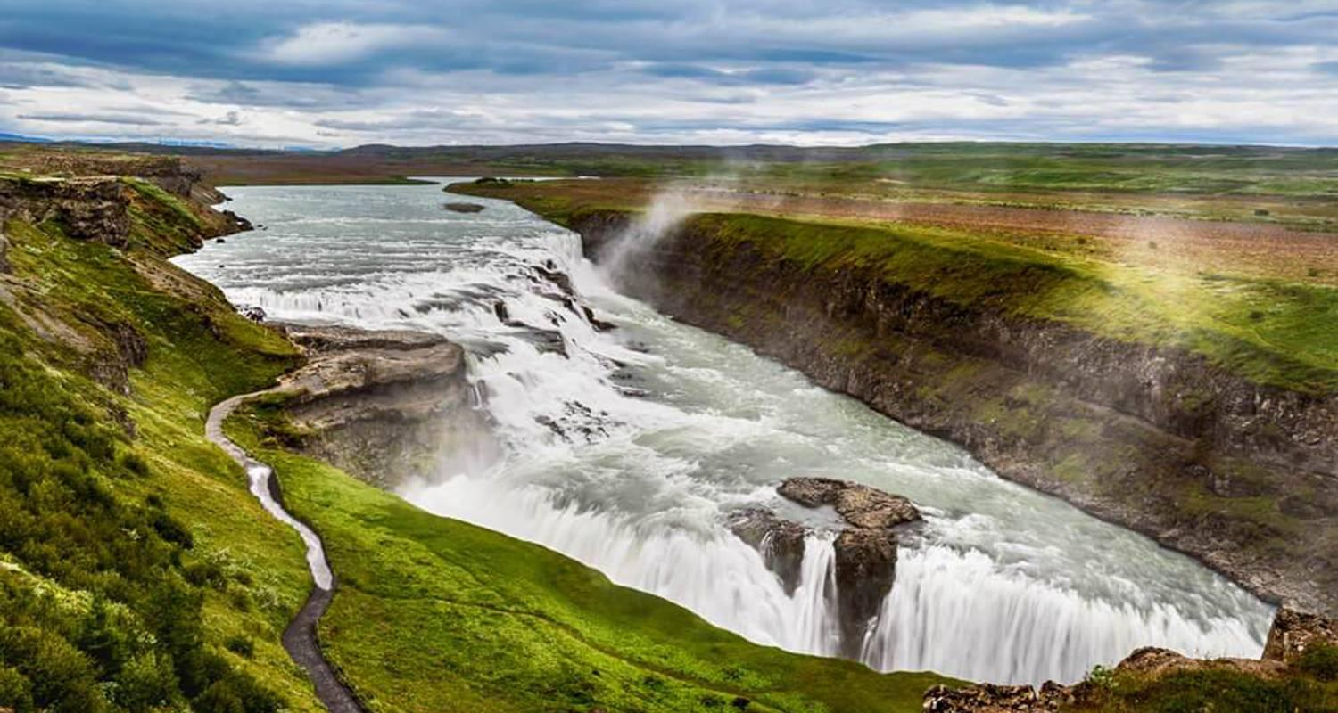

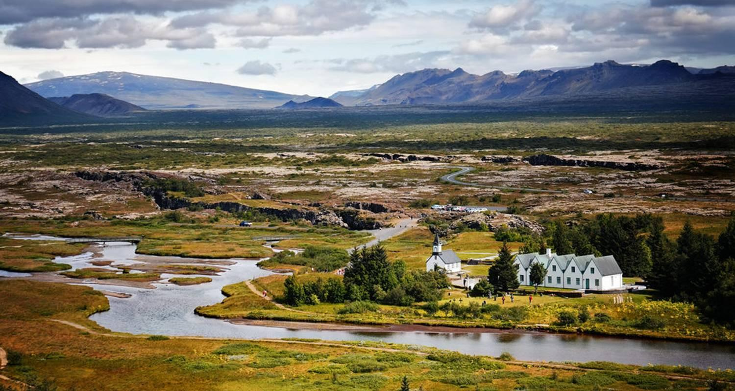

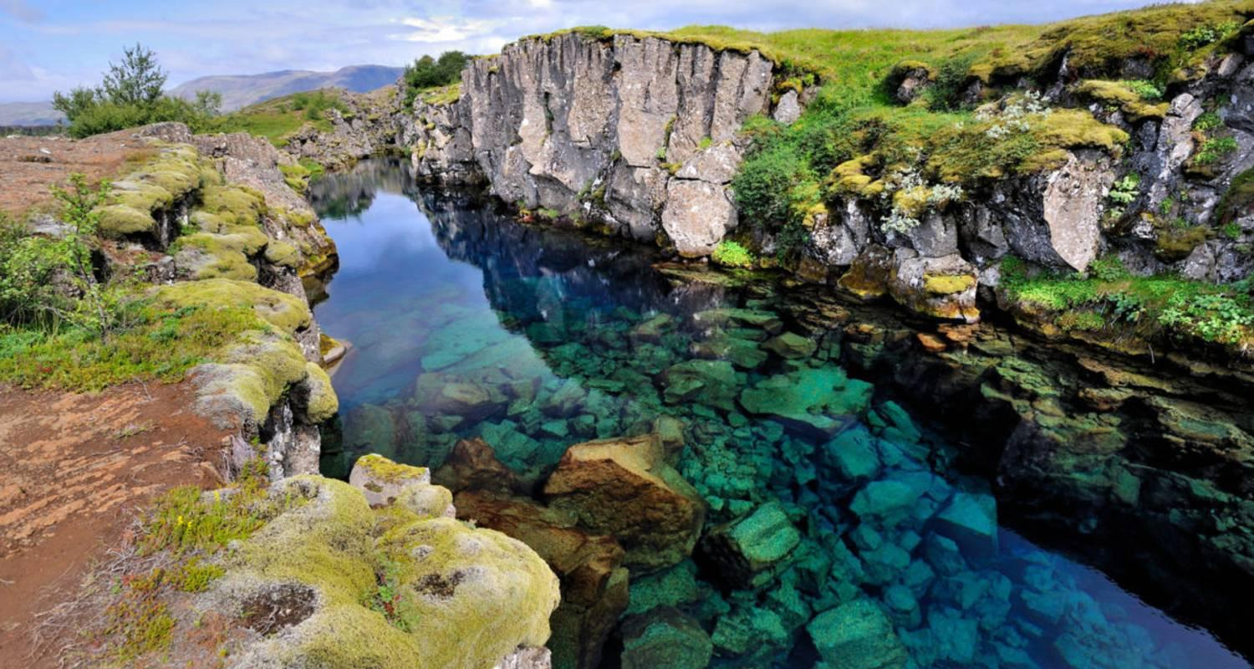

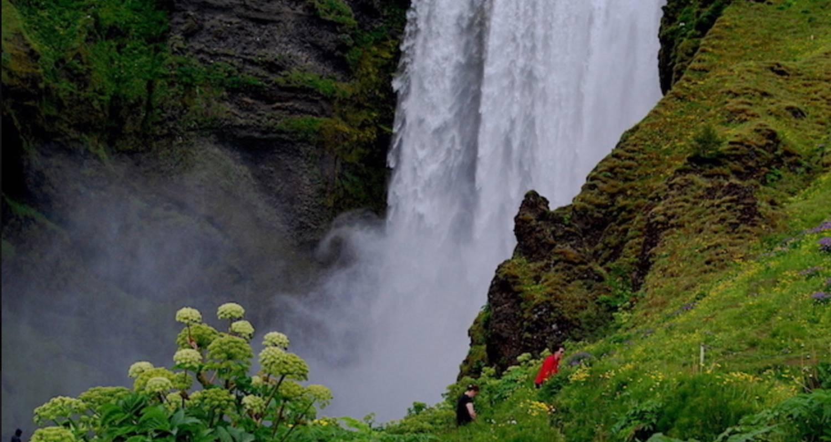

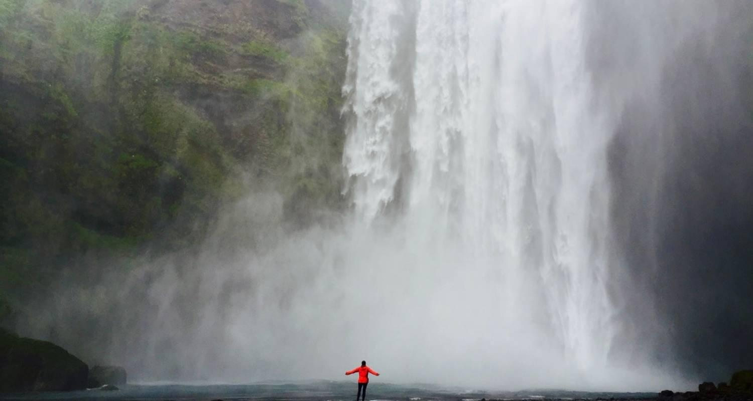

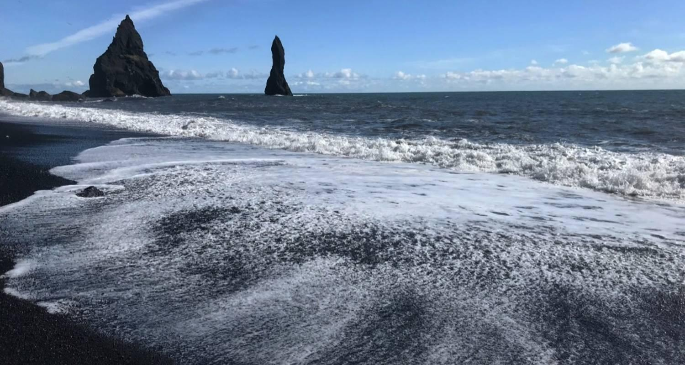

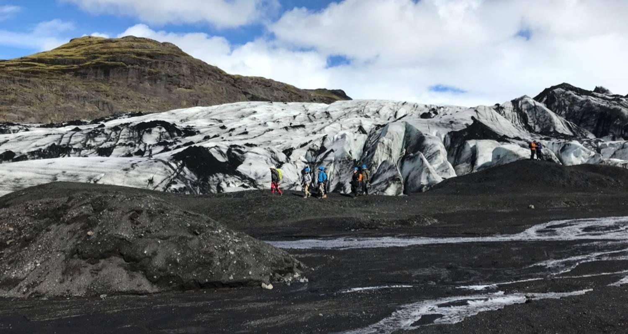

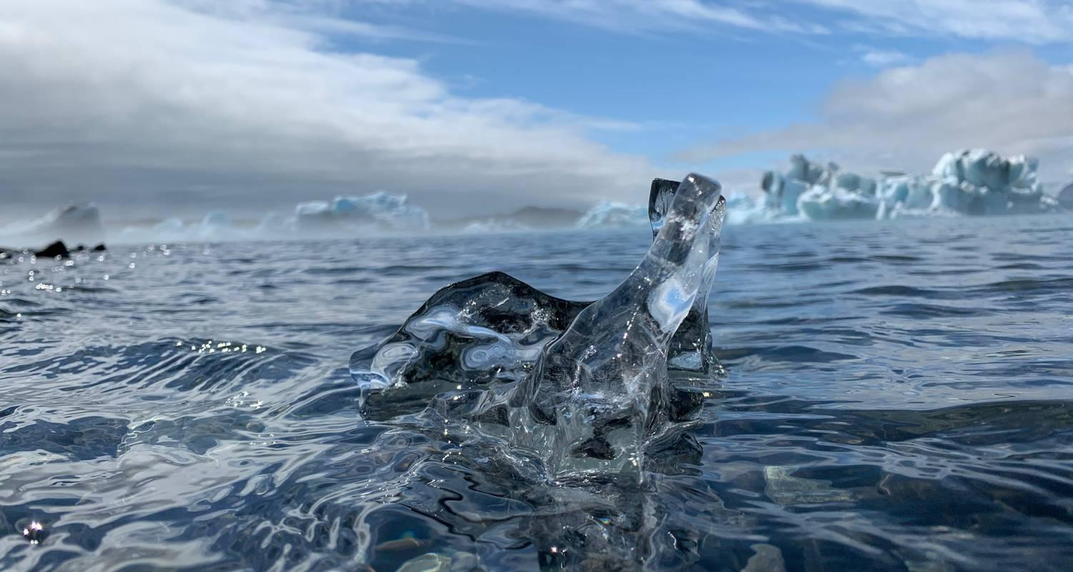

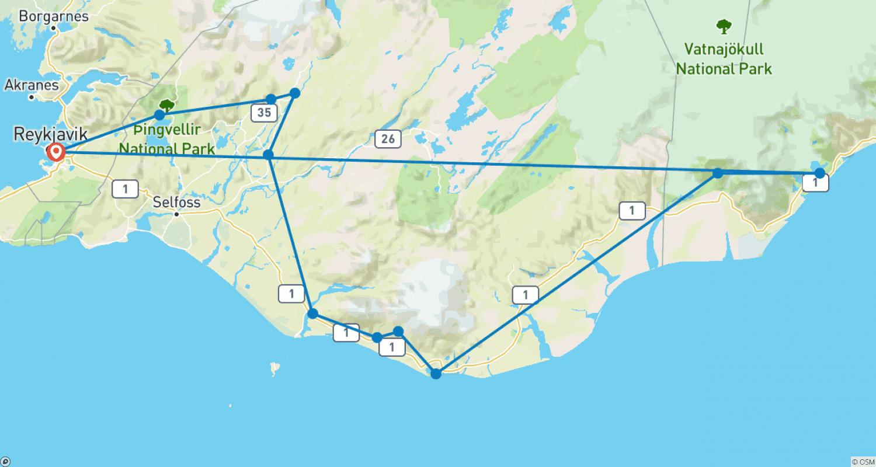

Tour ID: 194234  
Tour Name: 3 Day Akureyri and Mývatn - North and West Iceland - Private Tour

Tour destinations: ['Reykjavik', 'Hraunfossar', 'Borgarnes', 'Akureyri', 'Godafoss', 'Myvatn', 'Hverfjall Volcano', 'Mount Namaskard', 'Grundarfjordur', 'Djupalonssandur', 'Hellnar', 'Arnarstapi']

Tour destinations images:

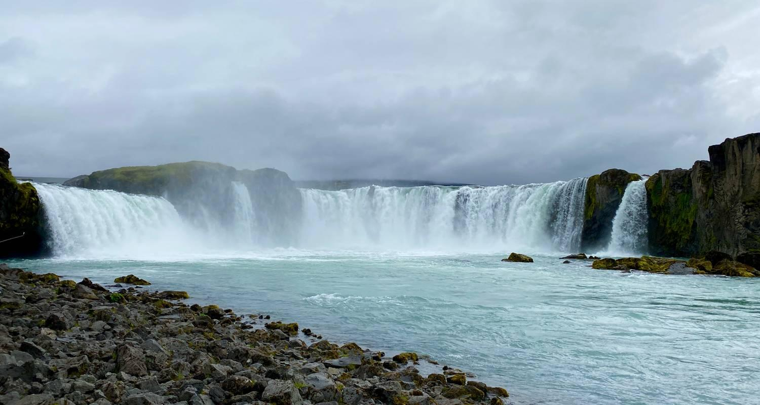

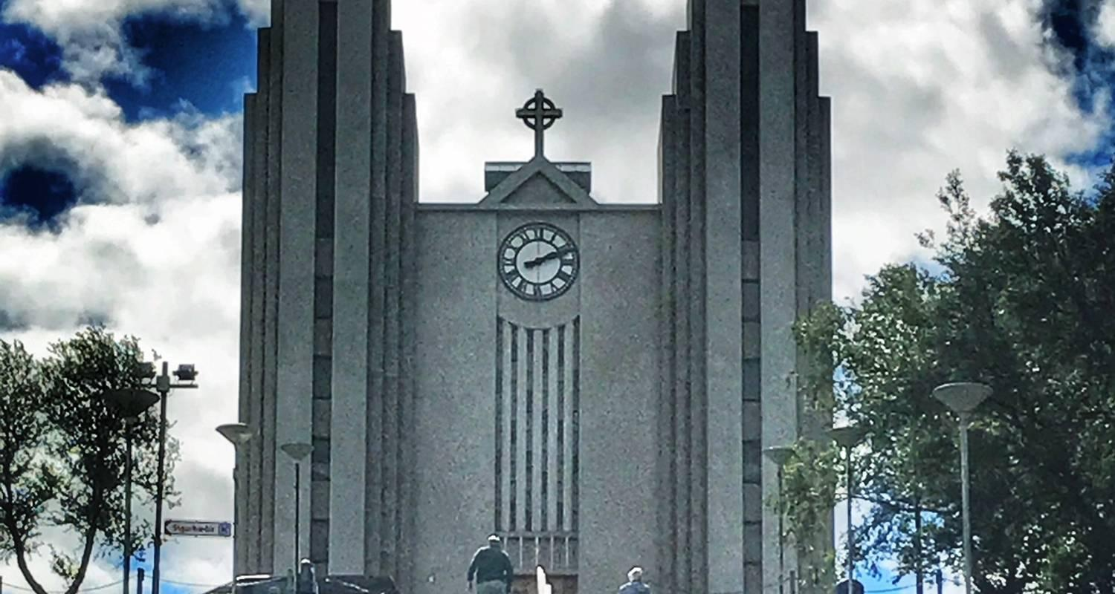

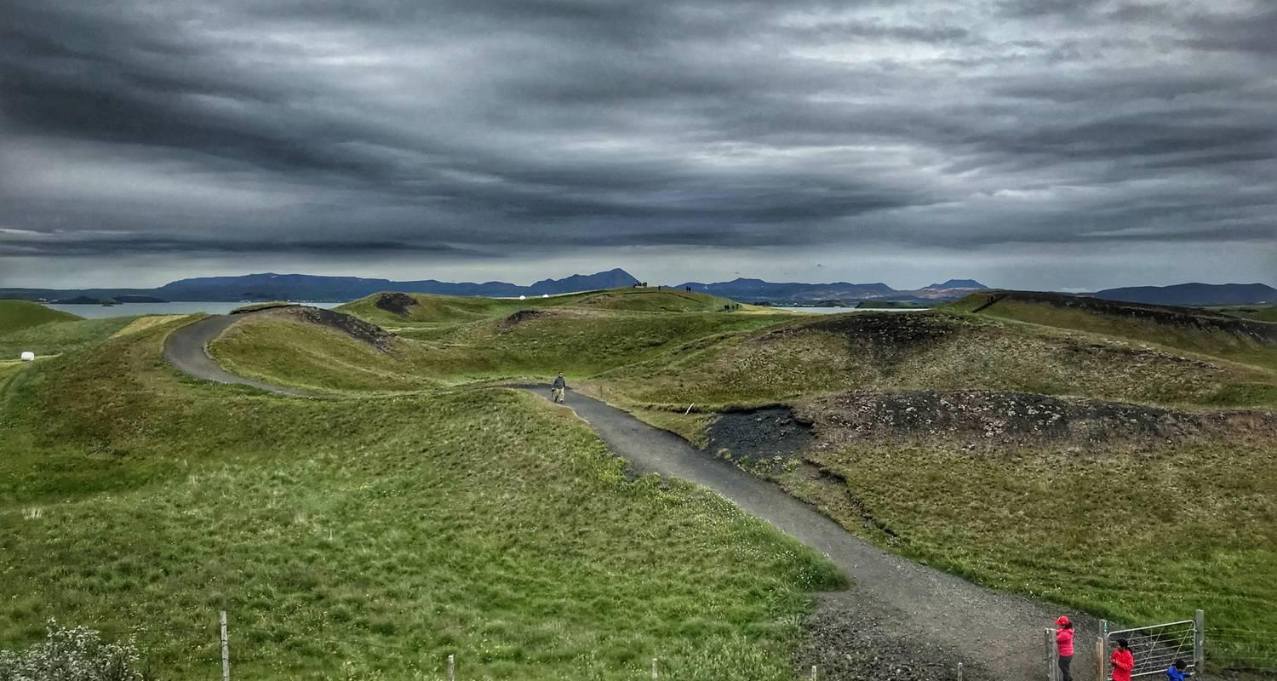

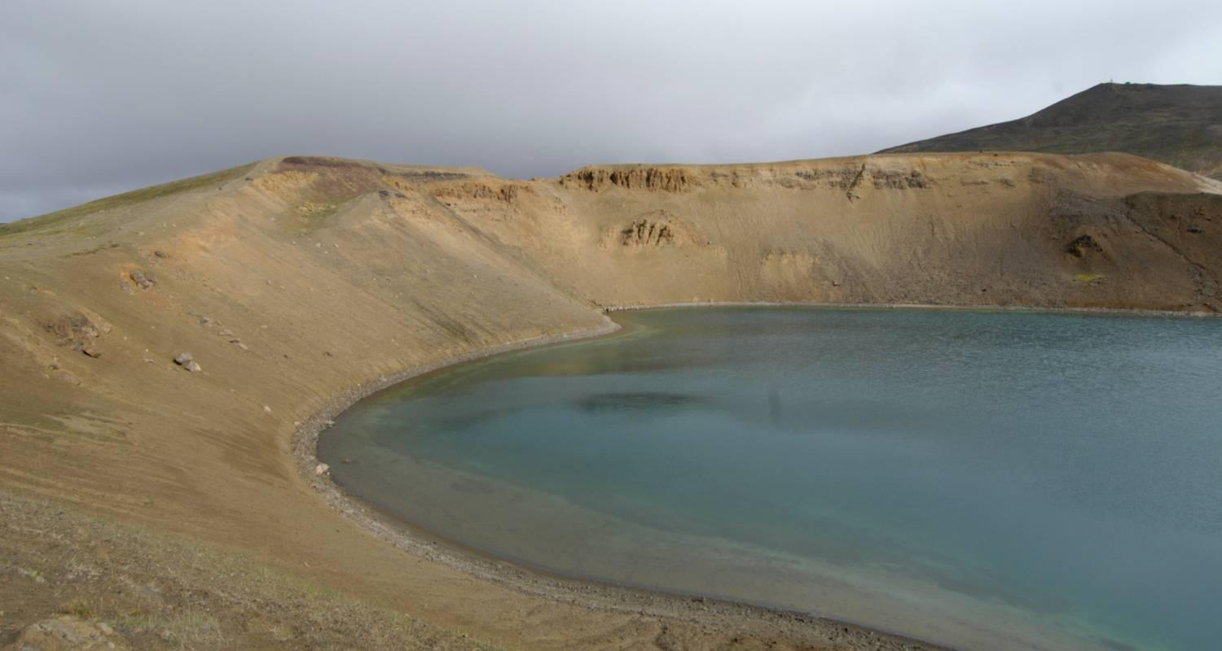

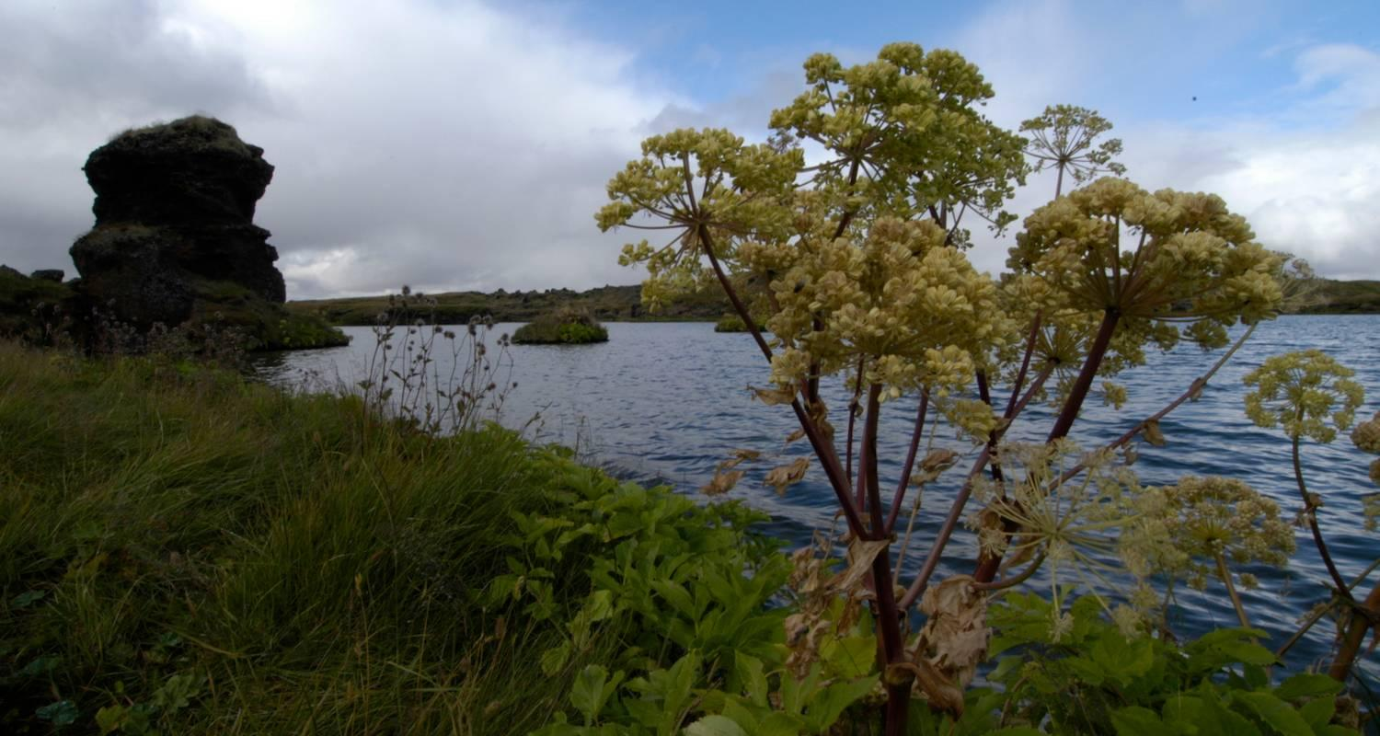

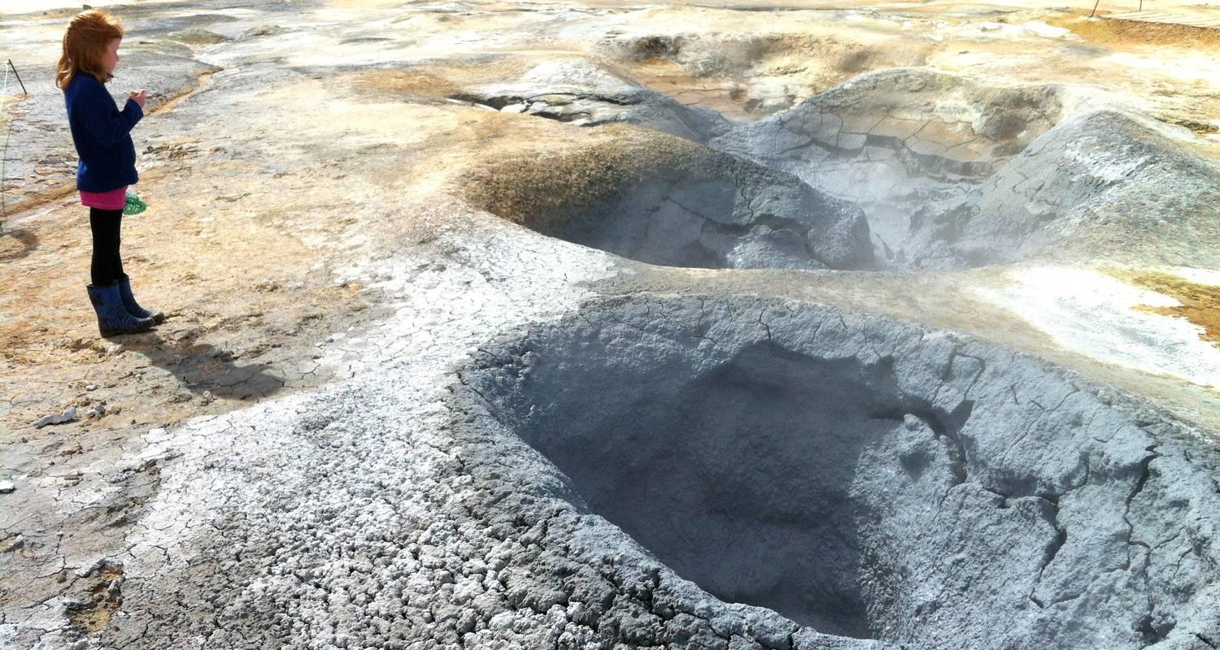

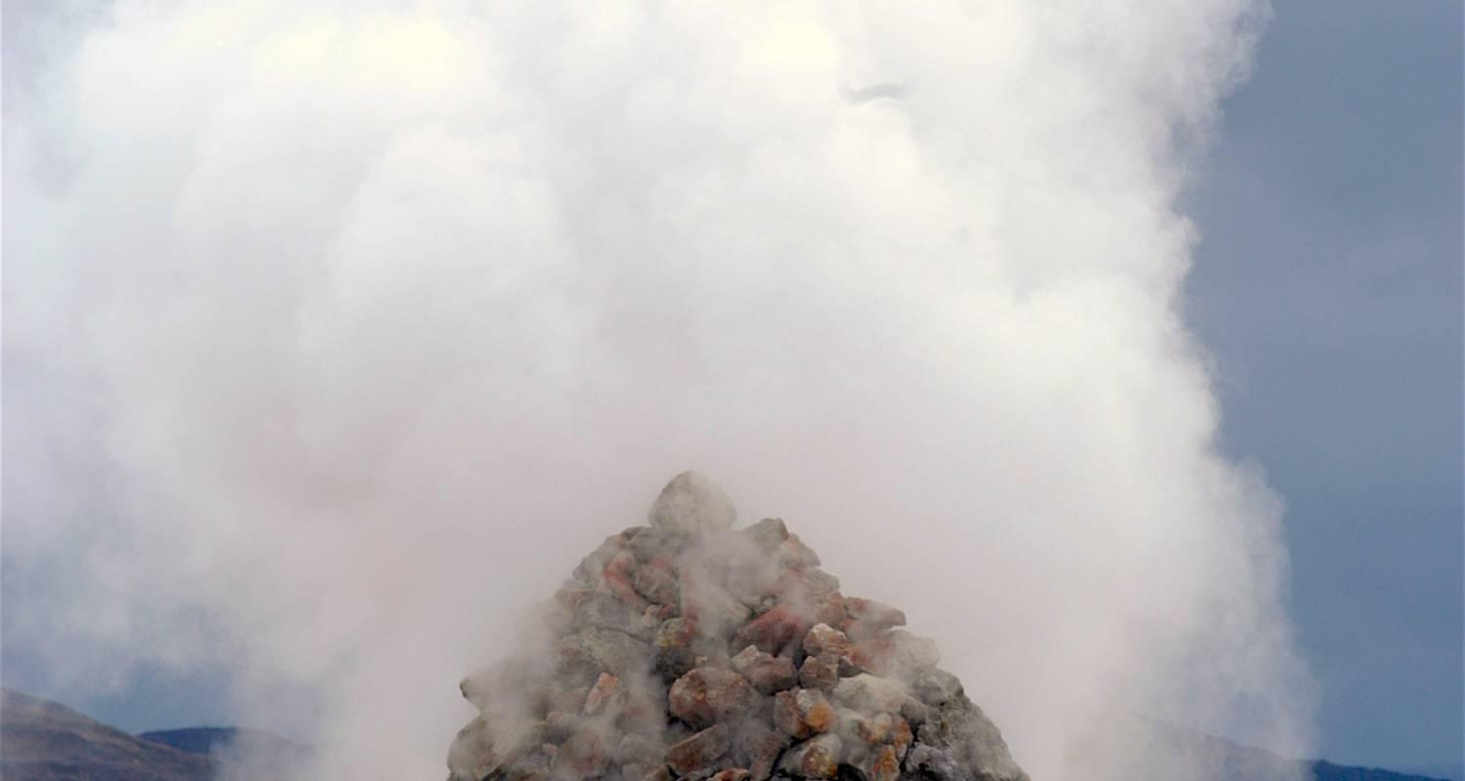

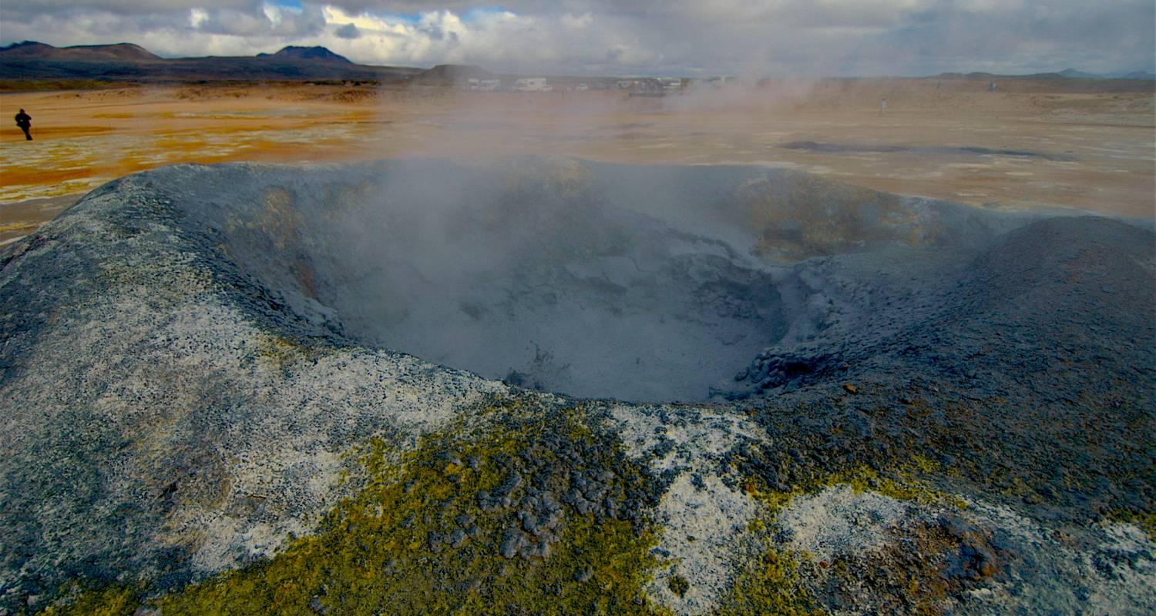

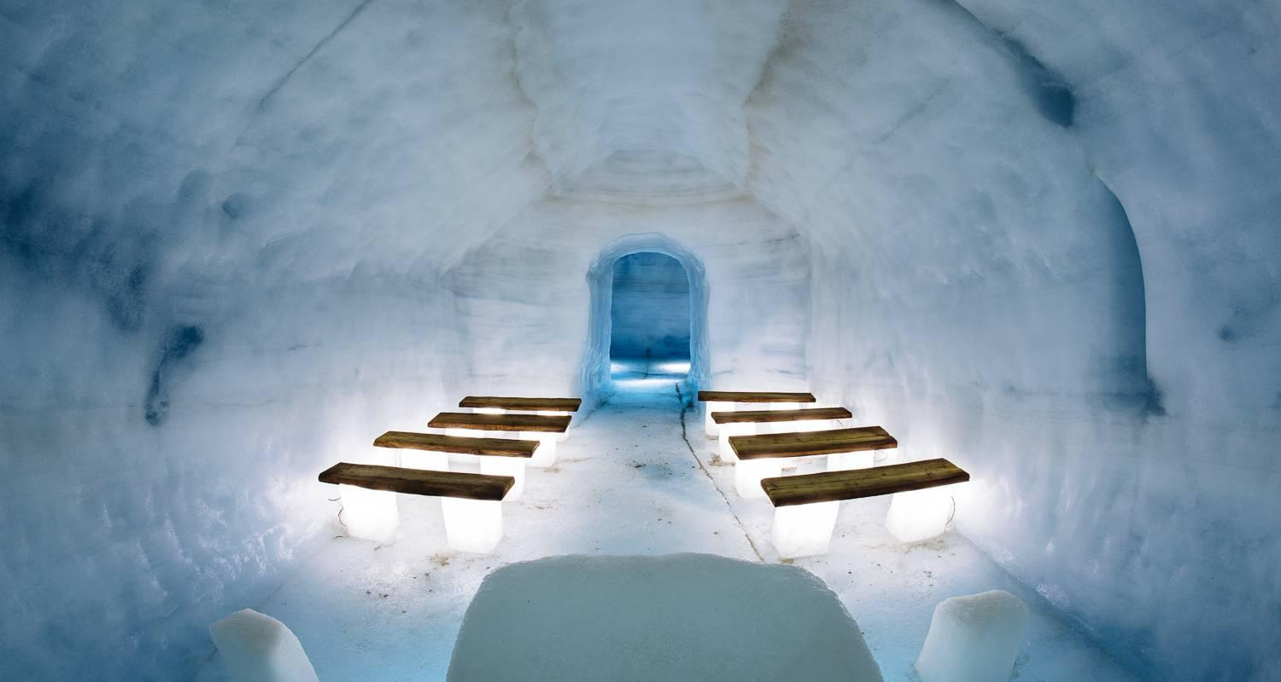

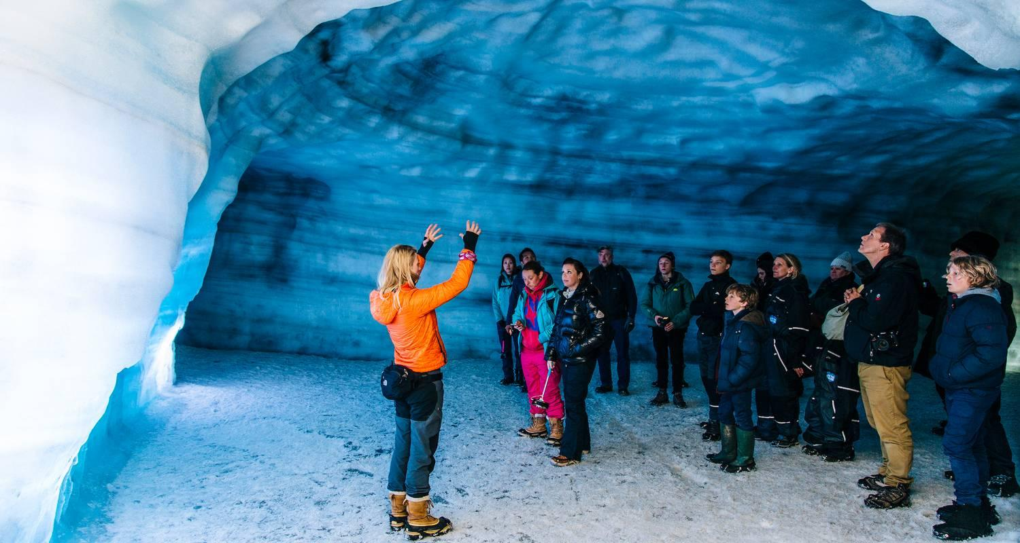

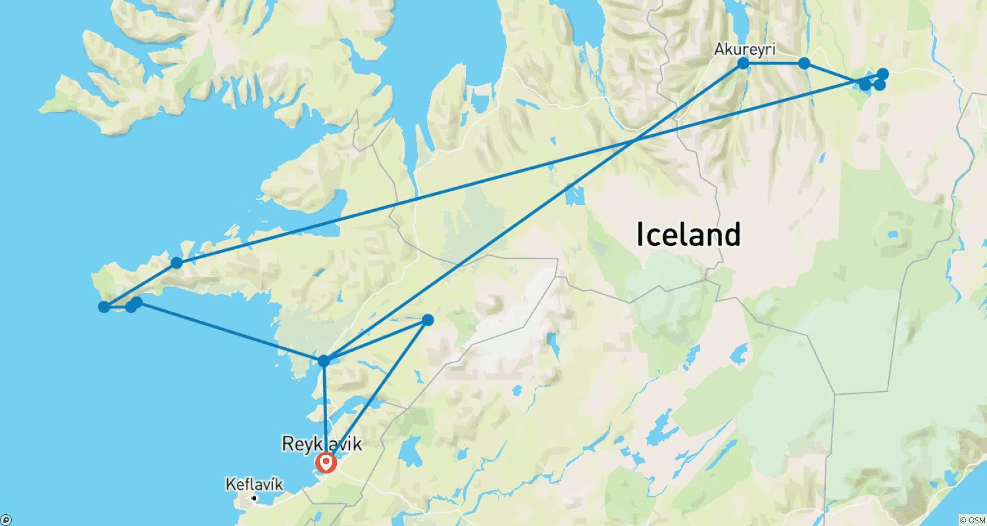

Tour ID: 195489  
Tour Name: 4 days South Coast, Golden Circle and Snæfellsnes (Group Tour)

Tour destinations: ['Reykjavik', 'Kirkjufell Mountain', 'Djupalonssandur', 'Arnarstapi', 'Geysir', 'Gullfoss', 'Thingvellir National Park', 'Selfoss', 'Seljaland', 'Skogafoss', 'Skaftafell', 'Hofn', 'Jokulsarlon', 'Reynisfjara']

Tour destinations images:

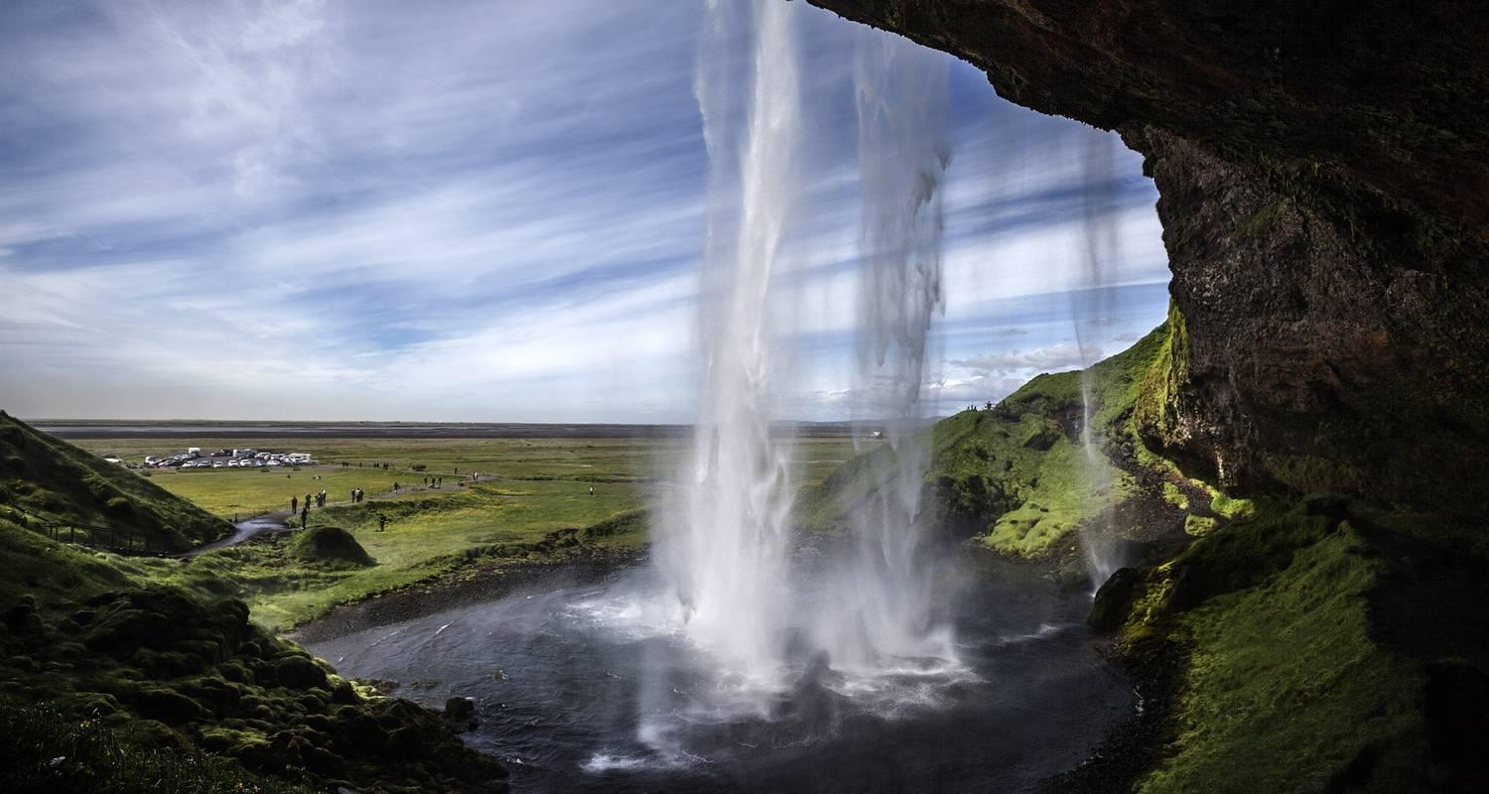

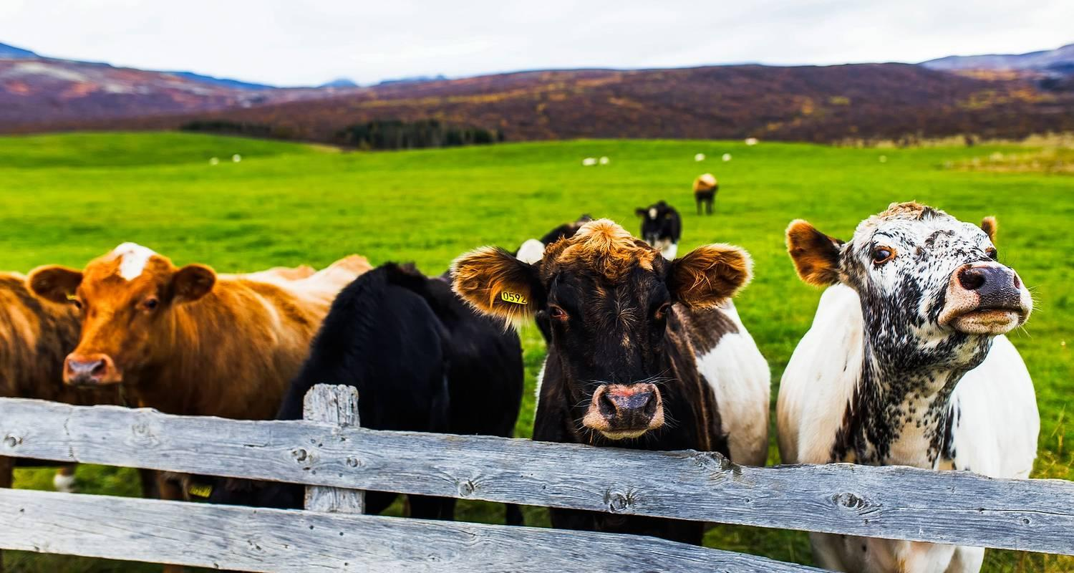

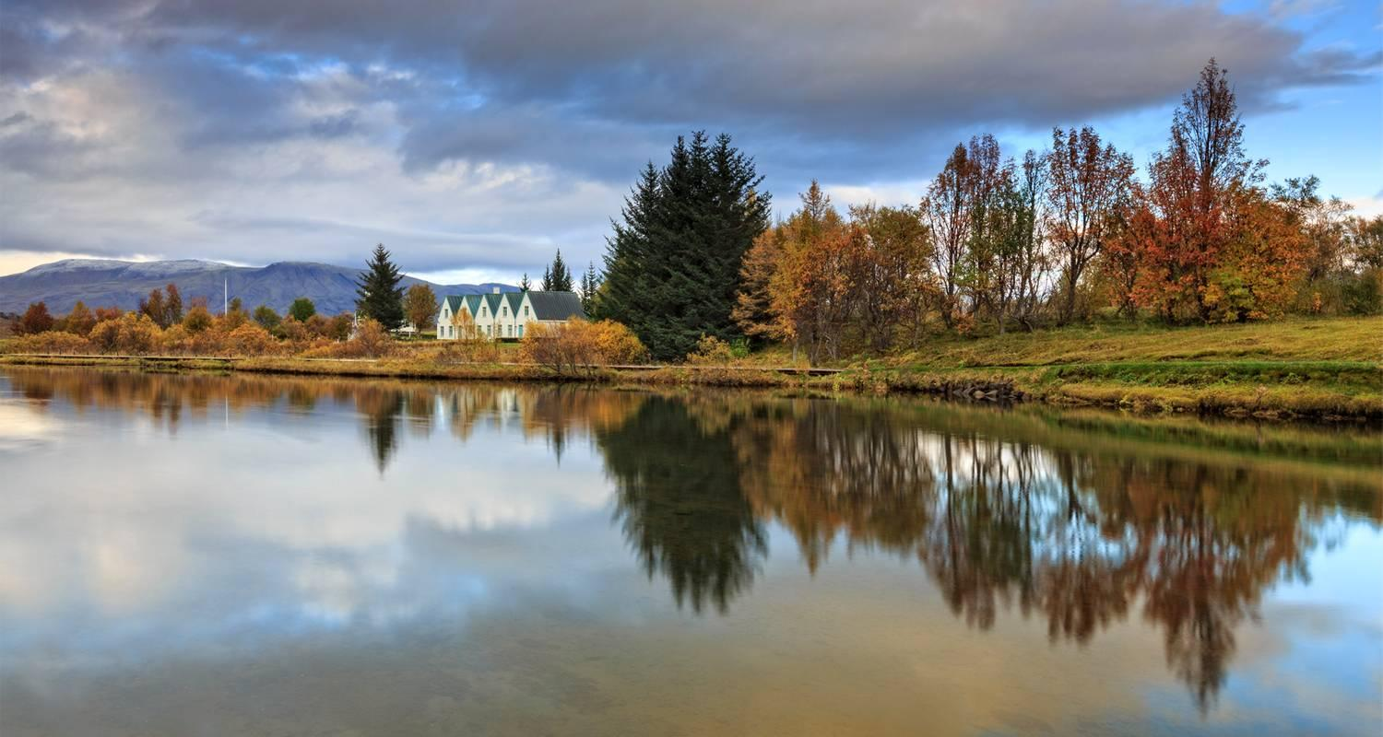

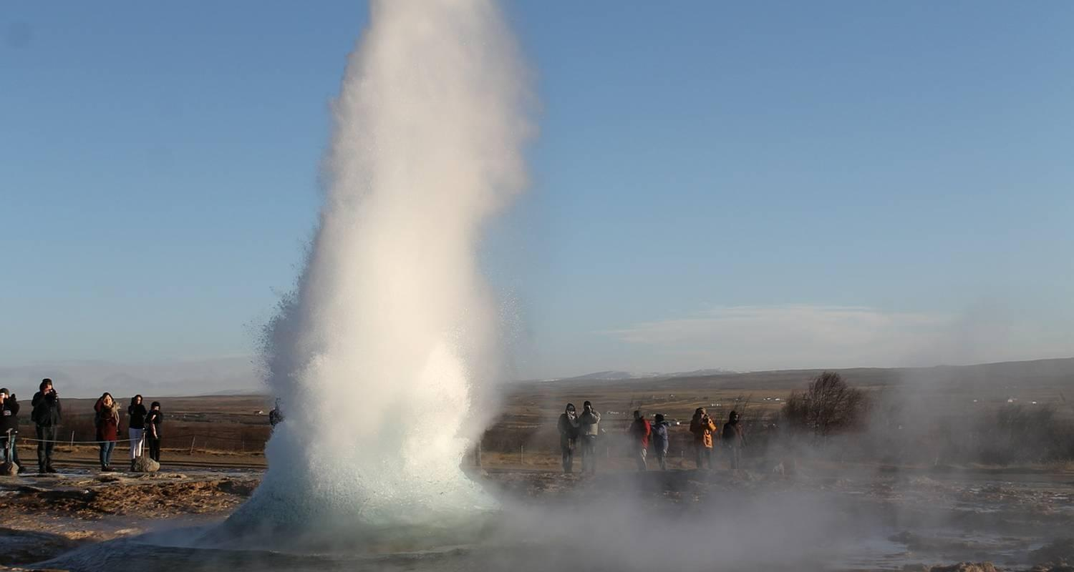

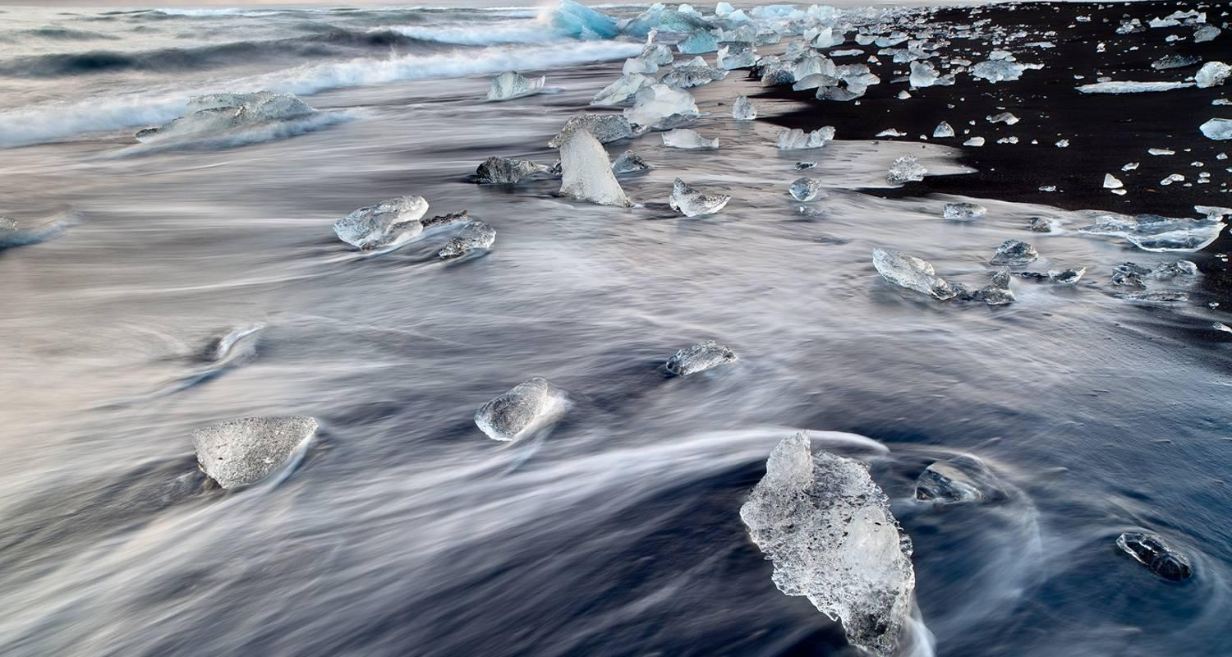

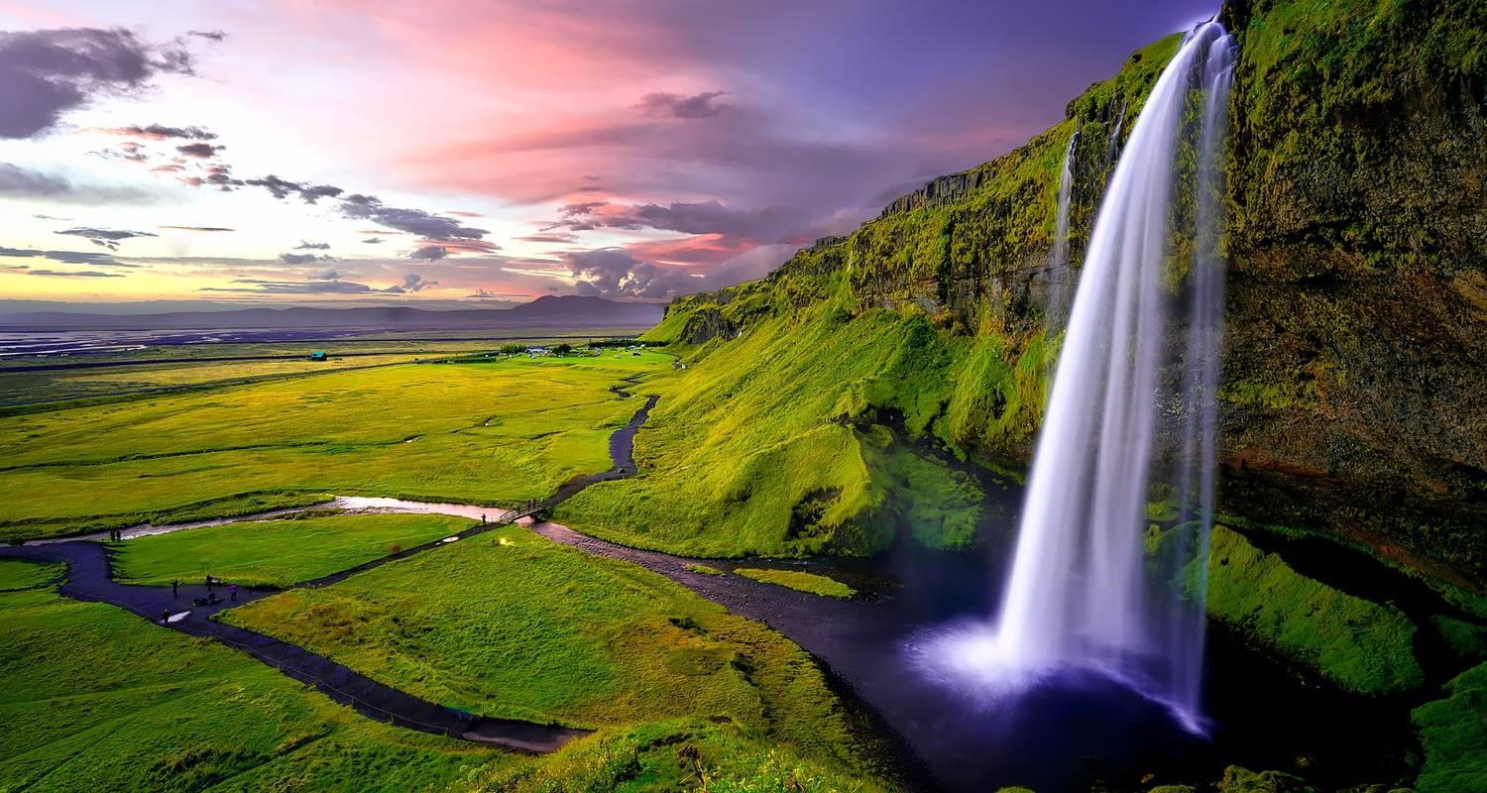

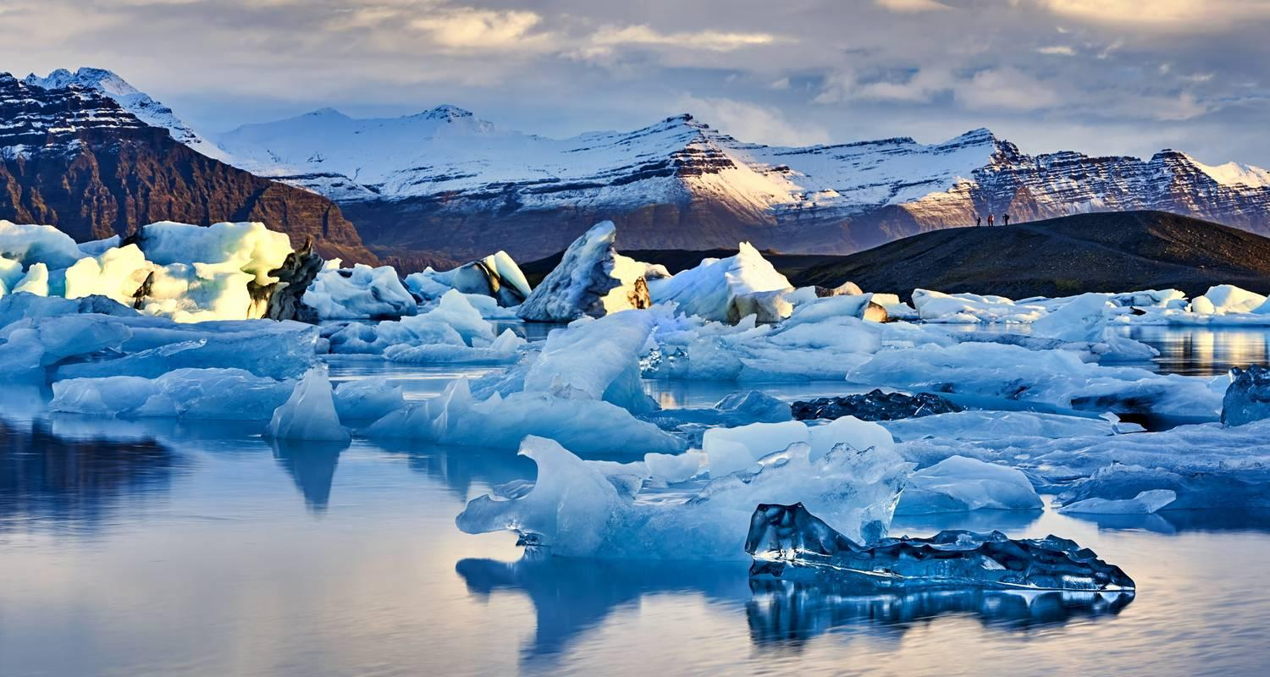

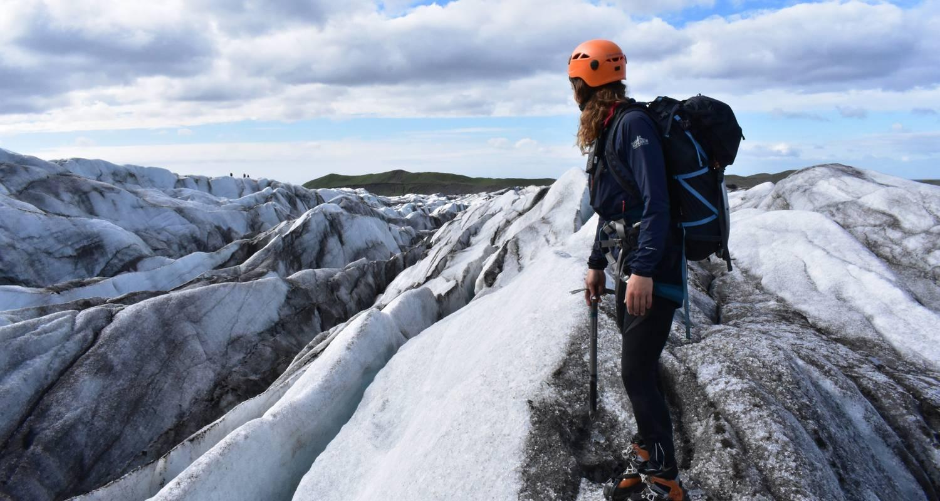

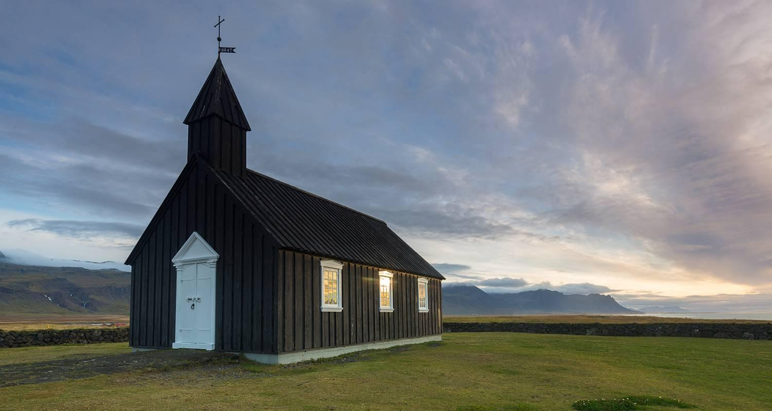

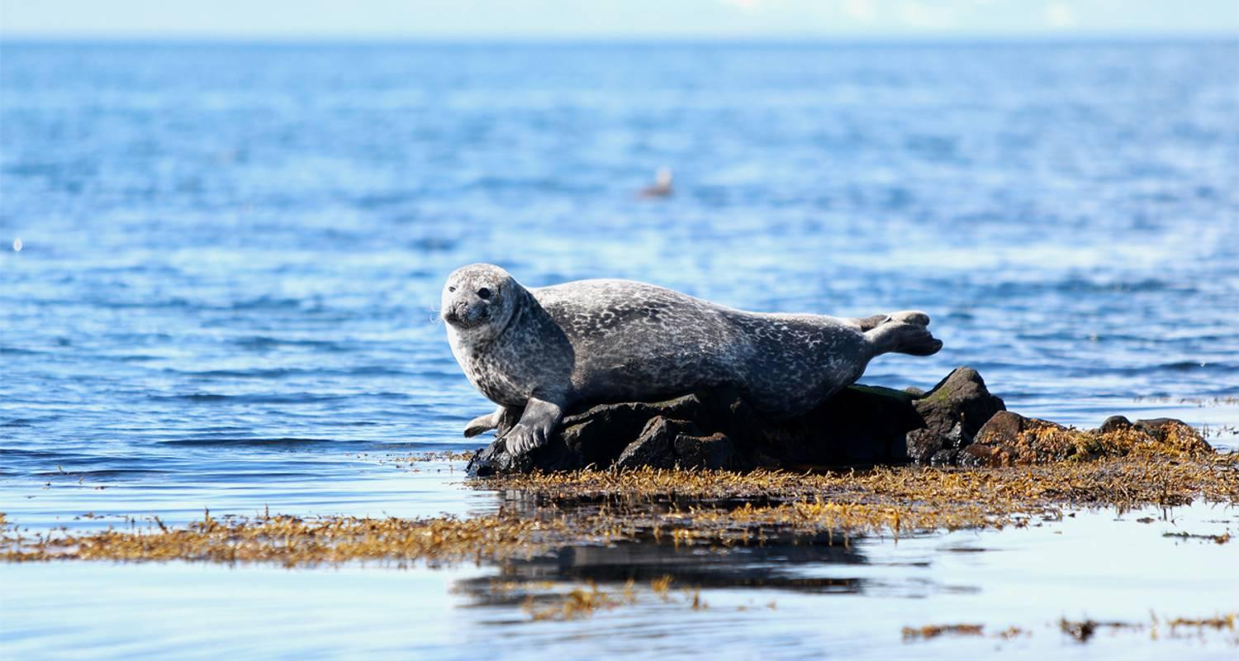

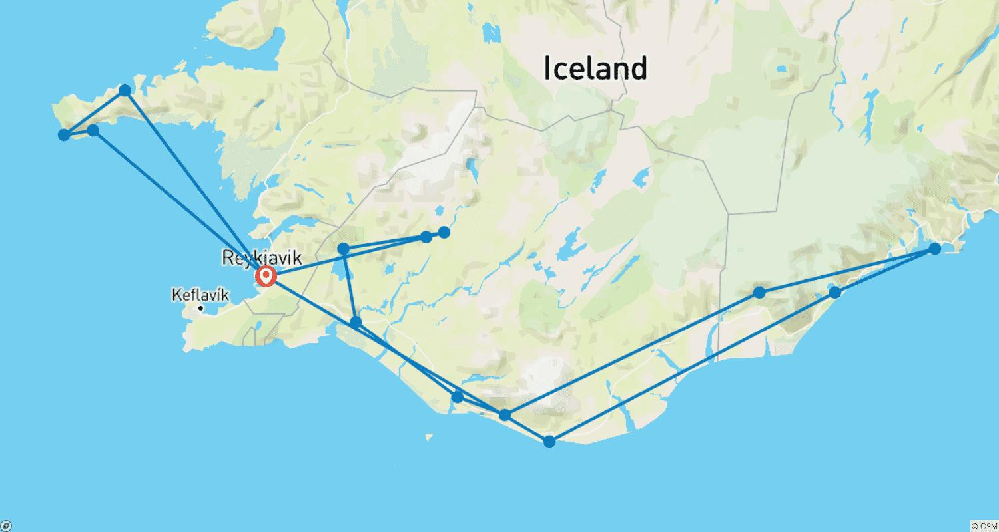

Tour ID: 195587  
Tour Name: Laugavegur Trek 4D/3N

Tour destinations: ['Reykjavik', 'Landmannalaugar', 'Hrafntinnusker Mountain', 'Emstrur', 'Thorsmork Nature Reserve']

Tour destinations images:

